Table of Contents
Introduction 2
Research 3
Background Research 3
Quantitative Research 5
Exploratory Survey 5
Conclusions 17
Branding 17
Tagline 18
Mission Statement 19
Alternative Logos 20
Brand Kit 22
Conclusions 23
Search Engine Optimization and Artificial Intelligence 24
SEO 24
AI Utilization 29
Conclusion 31
Social Media 33
Instagram 33
Meta Suite 37
LinkedIn 38
YouTube 39
TikTok/Reels 39
Conclusions 40
Website 42
Home 42
Promotional Services 44
Christmas Video Promotion 46
Recent Videos 47
About Us 48
Contact Us 50
Overall Findings 52
Bibliography 53
Survey 57

Introduction
Over eight weeks, a dedicated team from the University of Tennessee-Knoxville American Marketing Association took on a key project for Visual Image Marketing (VIM). This group of students, known as the AMAze Group™, was tasked with identifying and addressing VIM’s primary challenges through innovative and tangible solutions. Their objectives included developing a fresh tagline, redesigning the website, recommending strategies for search engine optimization (SEO) and artificial intelligence (AI), and creating compelling social media collateral. To address each goal strategically, the team segmented their approach into five key areas: Research, Branding, SEO/AI, Social Media, and Website. The key focus of all the AMAze Group’s recommendations is to maintain the essence of Visual Image Marketing and embody the original vision created by owner, Steve Baker, into the brand's identity.

Research

Background Research
The AMAze group initiated its research by conducting a competitive analysis of the competitors identified by Visual Image Marketing, which included AristoMedia, Rive, and HIP Video Promo. AristoMedia is a globally connected music promotion agency with an active social media presence on Instagram, Twitter, and Facebook and a wide-reaching promotional network that includes YouTube, Instagram, TikTok, Facebook, VEVO, CMT, and MTV. Their services are tailored to enhance artists' visibility through comprehensive marketing plans, including country music promotion, interview solicitation, broadcast and television appearances, online advertising, and music video distribution with post-production support. Additionally, they handle events and show planning to further support artists’ public image and engagement. The company’s branding is minimalistic, using simple, monochromatic icons for each service to create a clean, memorable look. AristoMedia’s website tells the story of the company, describes its range of services, provides contact information, and includes a dedicated tab showcasing their previous work, allowing visitors a full view of their extensive experience and industry impact.
In a comparison between Rive and VIM, Rive displays a strong focus on engagement and content presentation. Their website’s homepage focuses on visual simplicity, featuring minimal text and emphasizing partnerships with well-known networks that match its target audience. The "About" section dives deeper into individual videos, showcasing articles that introduce key artists involved and highlight their relevance. Rive also prominently displays where its content is available, listing platforms like Roku, Apple TV, and Amazon Fire Stick under the "Watch TV" section. It uses horizontal layouts to allow for better video and artist visibility, while the "In the Spotlight" feature offers brief artist bios and accomplishments. Pricing packages are clearly outlined with bold letters to immediately capture attention, and custom proposals are offered. The "How to Get Started" section provides a clear step-by-step guide for users to engage with the platform. Rive also highlights its partnerships with major music video outlets like MTV, YouTube, Vevo, and Vice in the "Partners" section.
HIP Video Promo caters to a broad client base, from independent artists to major labels, by offering services in music video promotion, social media marketing, and Spotify promotion. Their website is structured to highlight each service category: the Music Video Promotion section outlines the media outlets they collaborate with and provides examples of successful clients, while the Social Media Marketing and Spotify Promotion sections detail how they boost artist visibility on key platforms. An extensive client list showcases every artist they've worked with, linking to profiles and videos for an interactive view of their work. The "Why HIP?" section explains the unique value they provide, complemented by an "About Us" page that shares the agency's history and introduces staff members. Testimonials from satisfied clients add credibility, and a blog offers industry insights. HIP Video Promo also maintains a strong social media presence across Facebook, X (formerly Twitter), Instagram, YouTube, and TikTok, featuring a podcast with artists and Spotify playlists that further promote their clientele. Finally, they engage their community with a mailing list, ensuring both clients and fans stay informed about the latest updates and artist projects.

Quantitative Research

Exploratory Survey
The AMAze group conducted an exploratory survey to collect real data from Visual Image Marketings clientele to further understand the issues at hand. The survey was created through Google Forms and was live for over two weeks. The AMAze Group recognizes that surveying VIM’s current market demonstrates sampling bias, but also shows the behavioral patterns of select target audiences. The survey collected a total of seventeen responses. The following graphics represent data collected and insights learned.

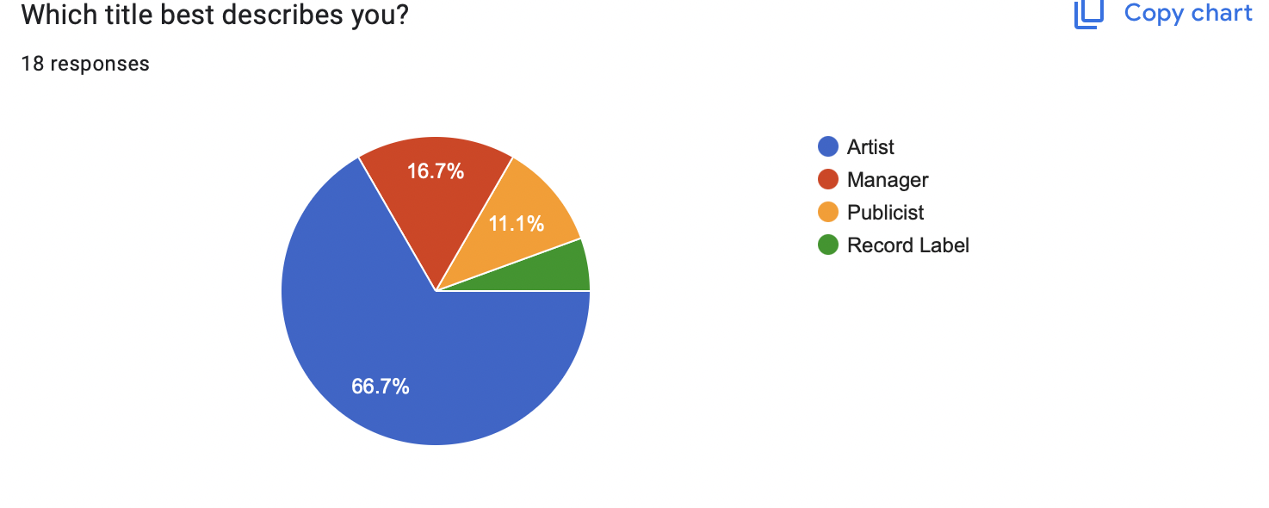
The chart illustrates the primary user demographics of VIM's services, with the majority of customers being individual artists, followed by managers, publicists, and, finally, record labels as the smallest group. This trend highlights that VIM's platform is predominantly tailored to the needs of artists themselves, who likely seek a direct and personalized way to promote their music and gain visibility.

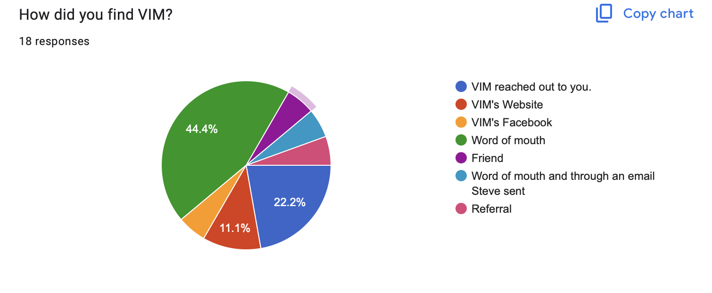
A significant majority of VIM’s clients discovered the company through word of mouth. This organic form of marketing not only highlights the trust and satisfaction that existing customers have in VIM’s products and services but also underscores the effectiveness of VIM’s community engagement and relationship-building efforts. As customers share their positive experiences with friends, family, and colleagues, it creates a ripple effect that enhances brand visibility and credibility. The AMAze Group recommends VIM create a Google Business Profile to increase word of mouth and website engagement. Through a Google Business Profile, Visual Image Marketing could gain customer insights, improve SEO, and interact directly with customers. Secondary research shows businesses that respond to a minimum of 25% of reviews, average up to 35% more revenue.

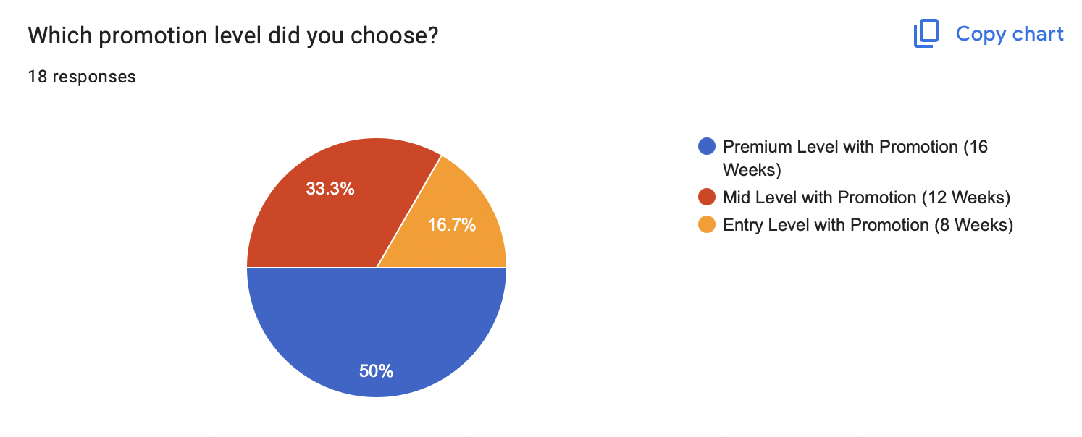
In VIM’s promotional offerings for music video campaigns, clients can choose from four distinct levels: Basic, Entry, Mid, and Premium. The Basic level provides promotion of video distributed to networks and video outlets across the US and Internationally. The Entry level is for the artist who sees the value of promotion and wants to stretch their marketing budget over several videos during the year. Notably, 50% of VIM’s clients have opted for the Premium level, which includes comprehensive marketing strategies, personalized consultations, and extensive promotional support across multiple platforms. This strong preference for the Premium option underscores our clients' commitment to maximizing their impact and reaching broader audiences, demonstrating the value they place on a tailored, high-quality promotional experience.

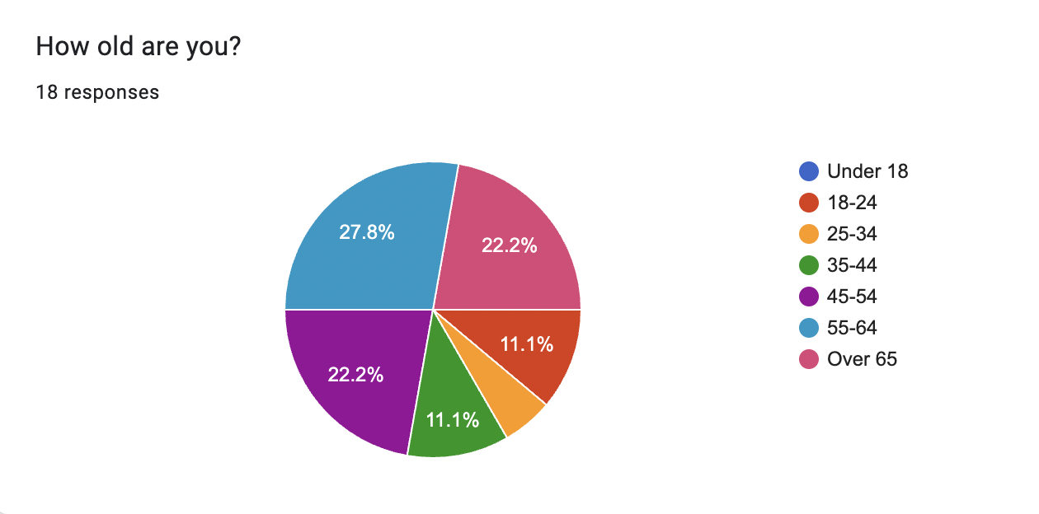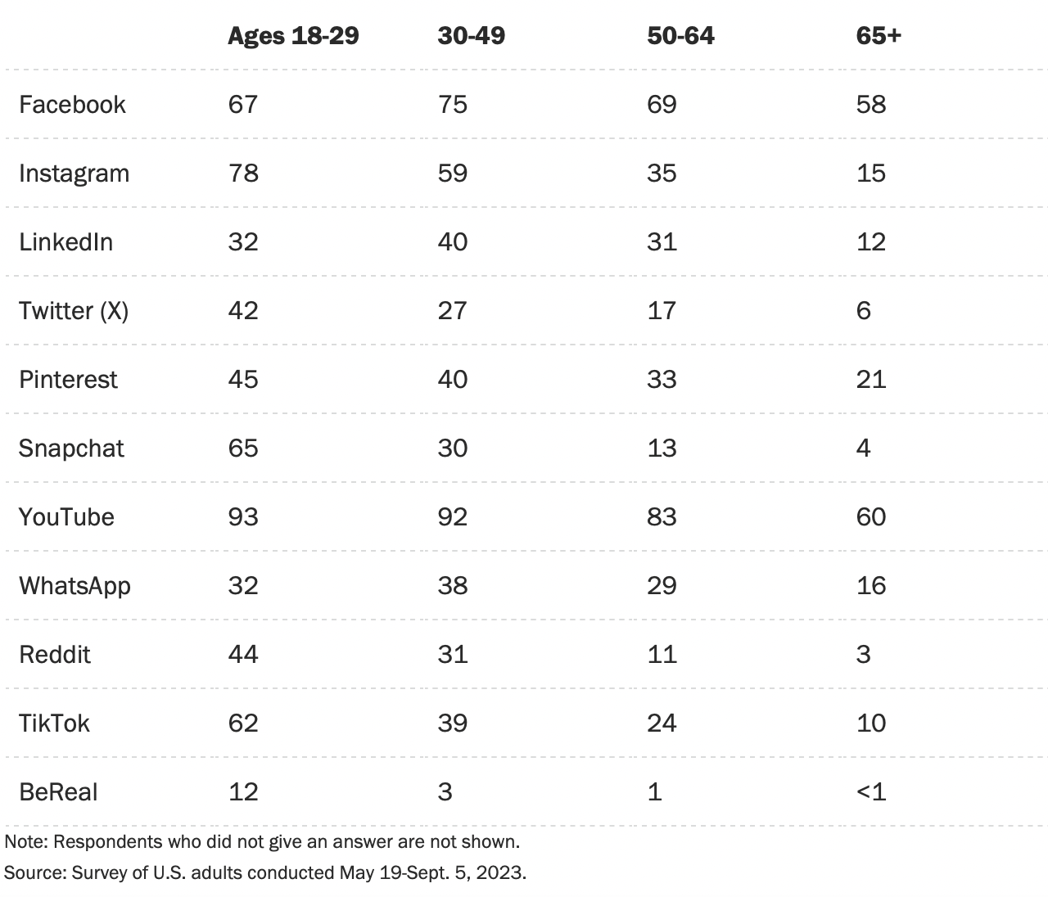
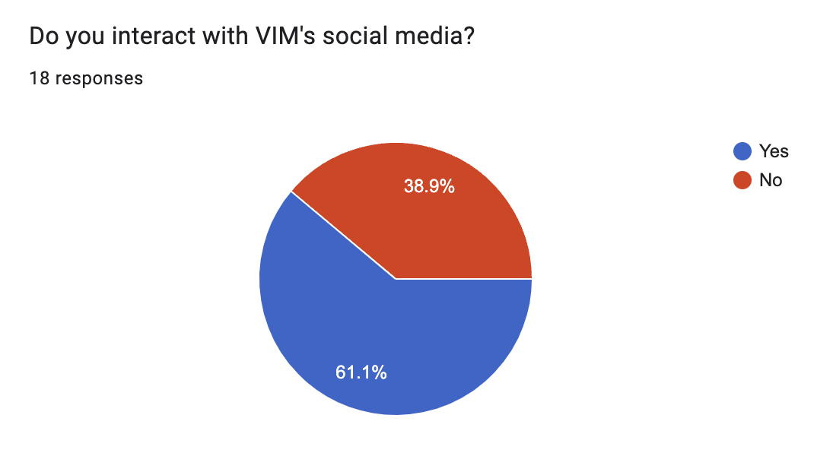
The majority of responses showed that 72.2% of VIM’s clients are 45 years old or older, and only 61.1% of VIM’s clients interacted with VIM’s social media. The most used forms of social media by age groups 50 years and older are YouTube, Facebook, Pinterest, Instagram, and WhatsApp according to the Pew Research Center. Given this information, VIM should consider leveraging YouTube and Instagram as key platforms for outreach. Research indicates that this demographic not only consumes content on these platforms but also values the visual and interactive nature of the content available. Based on exploratory research, the AMAze Group believes that the engaging format and compelling design of these platforms will make VIM’s website more maneuverable and interactive. By creating targeted, engaging content on YouTube and Instagram, VIM can also effectively connect with and expand its reach among this influential age group to gain more clients.
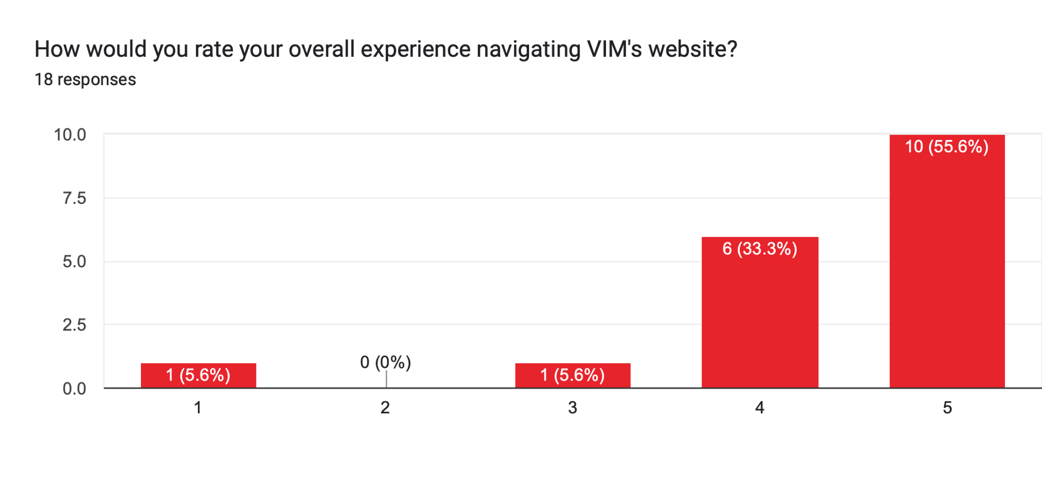
In the user feedback analysis, the AMAze group found that while the majority of respondents found navigating the website easy and intuitive, a subset reported that they encountered some tricky areas that hindered their experience. This divergence in feedback highlights the importance of continual improvement, as most businesses aim for a navigation success rate of 100%. Understanding these varying perceptions is crucial for enhancing user satisfaction and ensuring a seamless experience for all visitors. The AMAze website team will delve deeper into these insights and discuss proposed enhancements later in the presentation, focusing on how VIM can address the challenges identified and elevate the overall usability of the site.

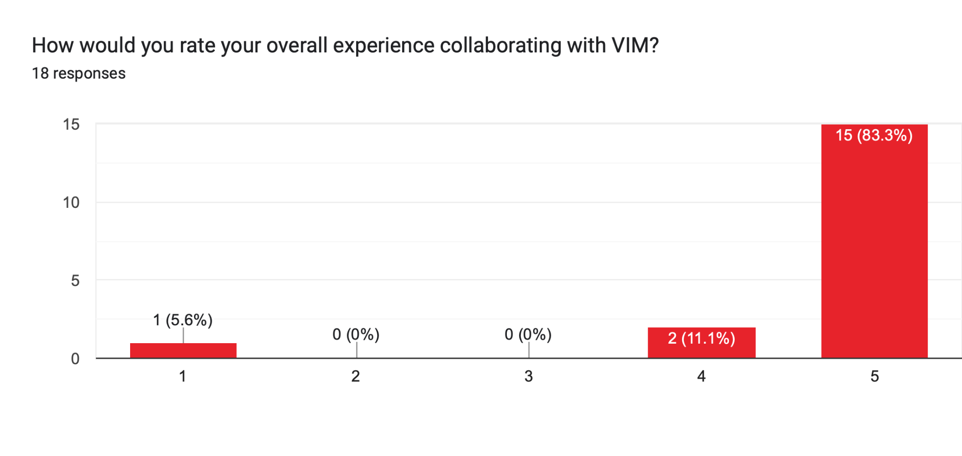
The feedback from the survey indicates that most respondents expressed a willingness to give a high rating for their overall experience working with VIM, reflecting the positive relationships built and the satisfaction with the services. However, it’s essential to recognize that every business aspires to achieve a 100% satisfaction rate. While the majority of responses are encouraging, the AMAze Group understands that there is always room for improvement to ensure that VIM not only meets but exceeds clients' expectations in every interaction.

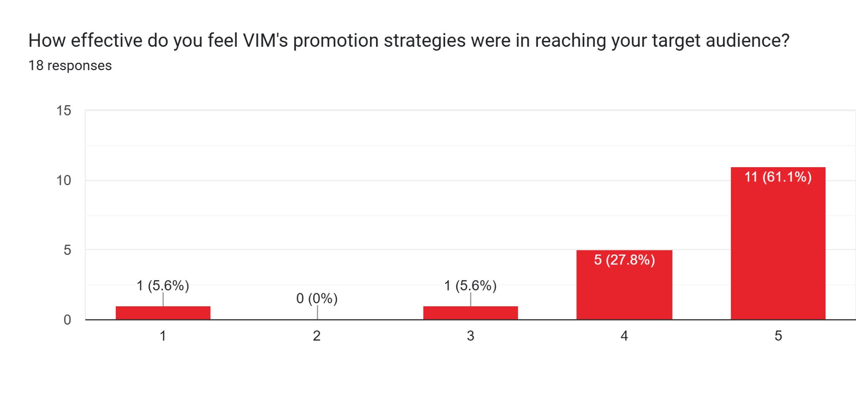
A significant 61% of respondents reported that they felt the strategies of VIM were extremely effective. This strong positive feedback highlights the success of VIM's approach in engaging its intended audience. Around 11% of participants indicated that they found the promotion strategies not effective or somewhat effective, suggesting that while there is room for improvement, the overall perception of VIM's efforts is largely favorable.

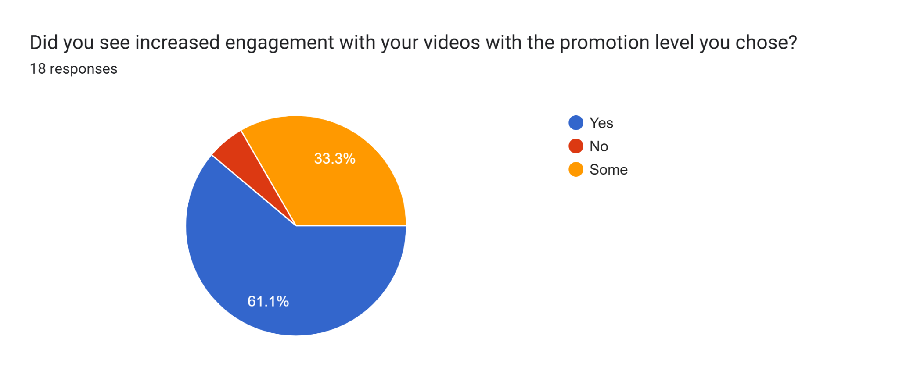
This graph displays that the majority of clients found increased engagement with the promotion level they chose, but over a third of clients felt as though the promotion they chose did not provide engagement for their videos. When researching competitors the AMAze Group found that other providers offer a Custom Promotion Plan. Through a Custom Promotion Plan offering VIM can showcase its personalized touch and be able to set reasonable expectations for both VIM and the customer to reduce unmet expectations.

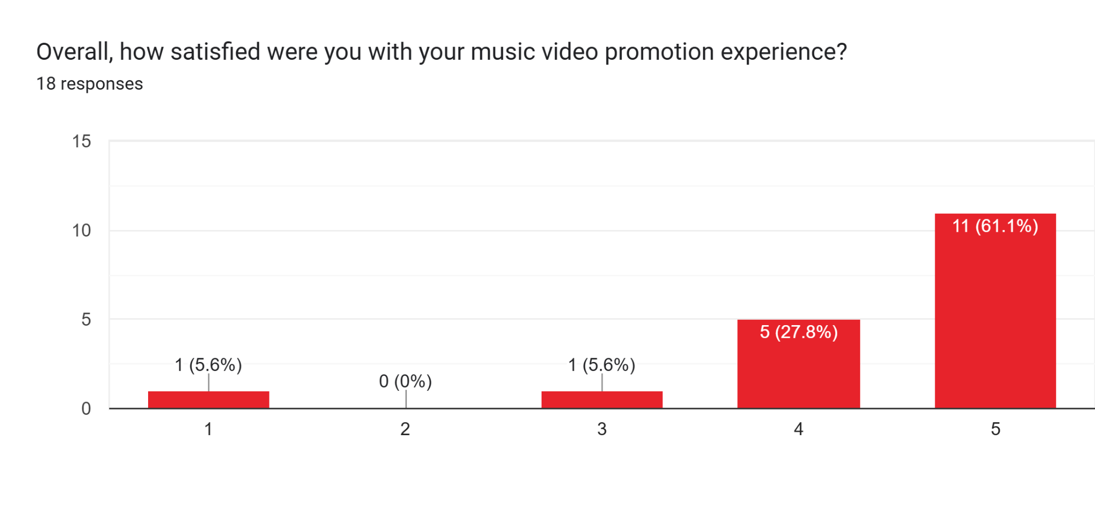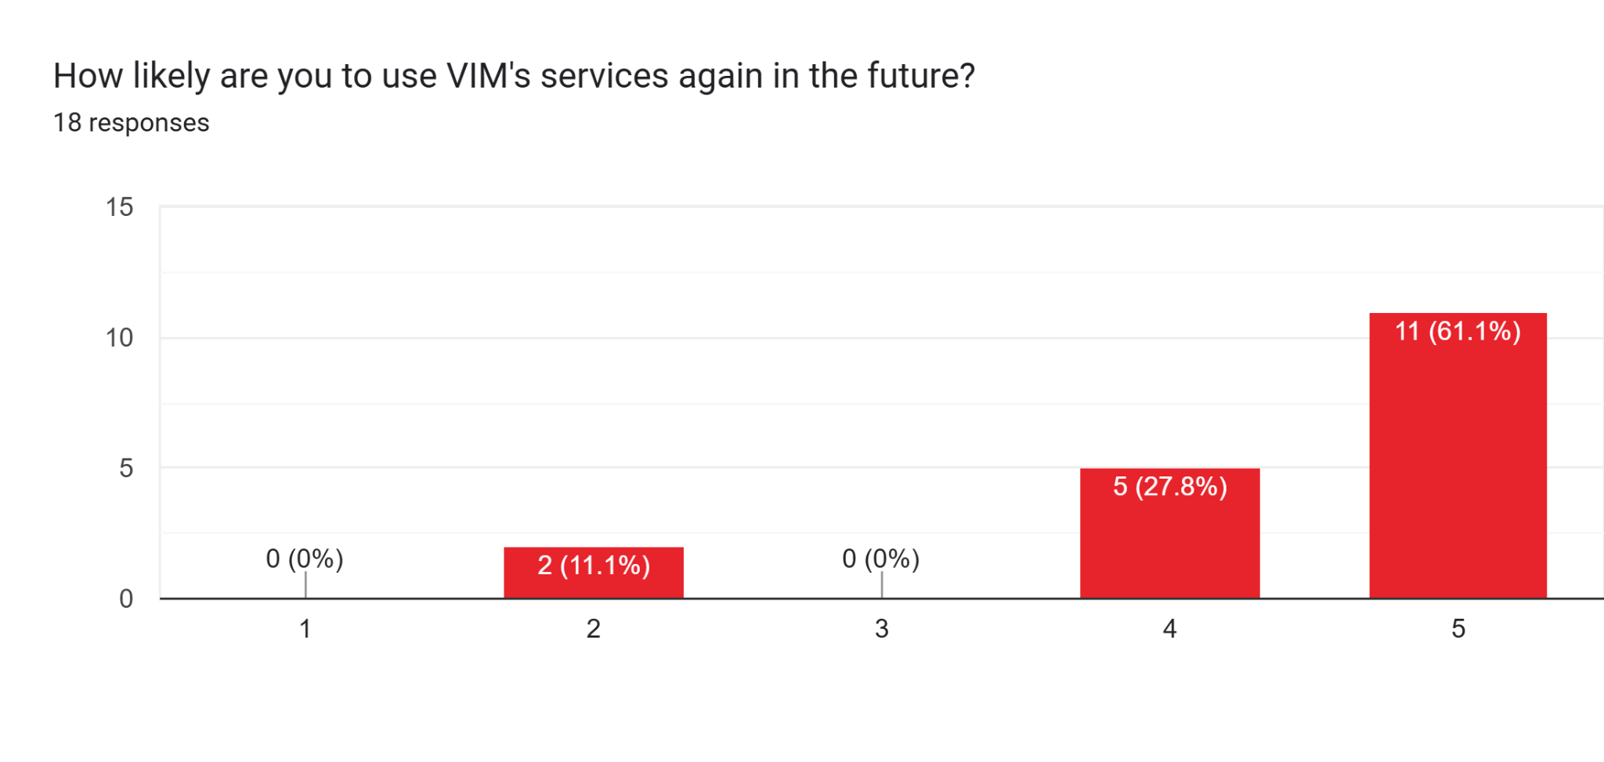
The survey showed that 61.1% of respondents are extremely likely to reuse VIM's services in the future and that they were satisfied with their experience, indicating that VIM can find a return customer in the clients that show complete satisfaction with their services. However, 11.1% of participants expressed that they are not likely to use the services again. This mixed feedback suggests that while the majority had a positive experience, there is a segment of customers who have unmet expectations that are preventing them from becoming return customers. In the future to receive more detailed feedback on why these customers are dissatisfied VIM could receive reviews using a Google Business Profile.

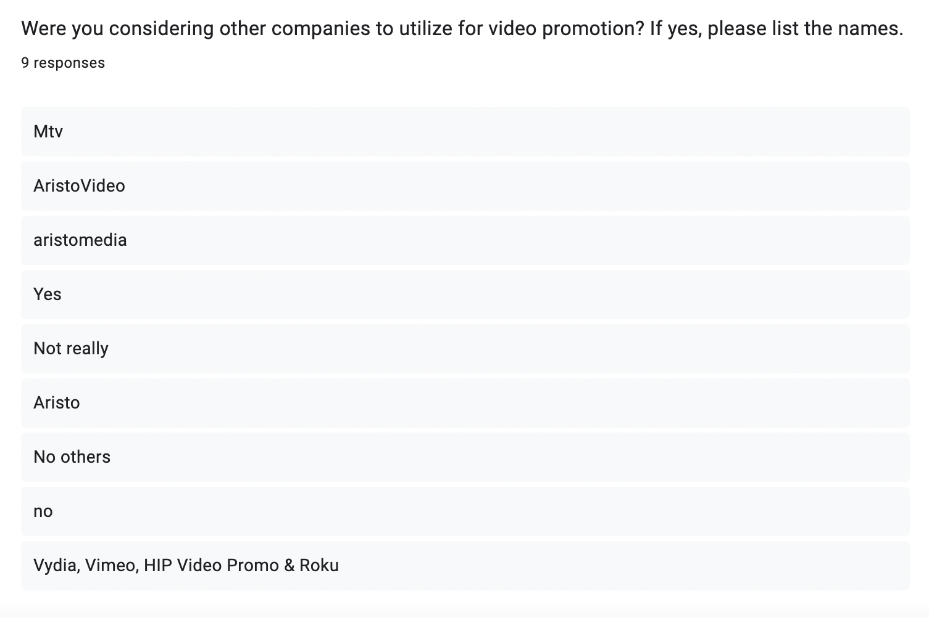
The AMAze group incorporated this question into the customer survey to enable VIM to gain insights into its competitors and facilitate a comparative analysis of its services against those offered by other companies. Through the survey’s responses, the AMAze Group has concluded that one of VIM’s biggest competitors is AristoMedia. After conducting exploratory research, the AMAze Group found that AristoMedia differs from VIM because they can be accessed through Twitter, Instagram, and Facebook; they use Instagram, Youtube, TikTok, Facebook, VEVO, CMT, and MTV as promotion outlets; and their services include detailed marketing plans, interview solicitation, broadcast and television services, online advertising, music video distribution and post-production, and event/show planning.
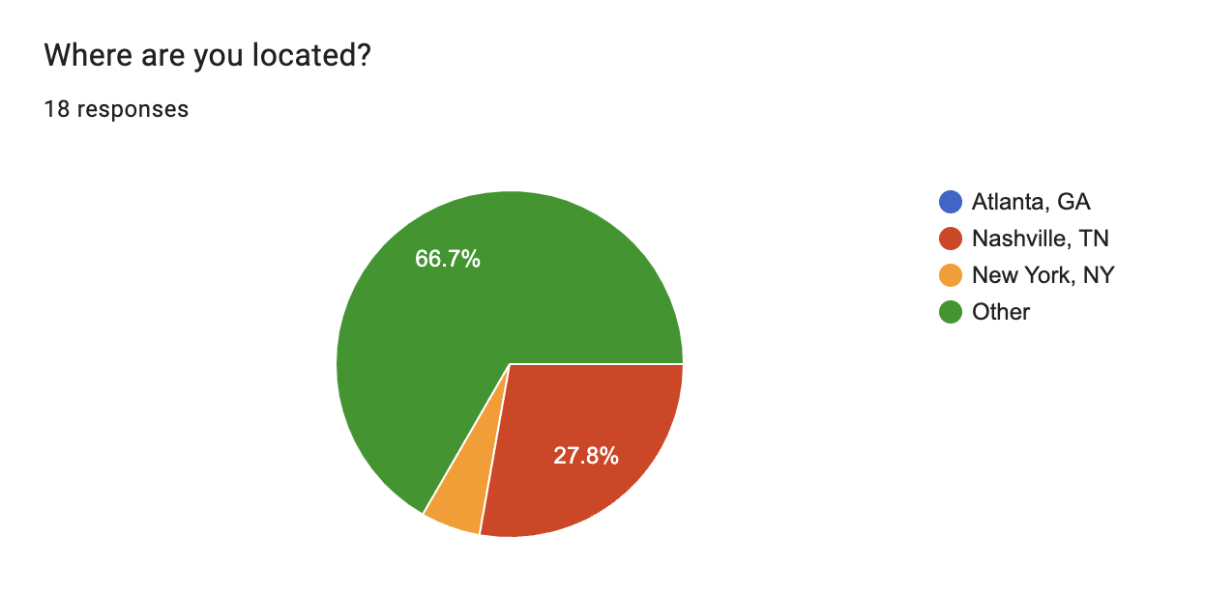
To maximize the reach and impact of your marketing efforts, it is crucial to target not only the local Nashville market but also those living in surrounding areas. The data obtained from the AMAze Group’s client form reveals that 66.7% of VIM’s clientele come from outside of Nashville, highlighting a significant opportunity to broaden VIM’s advertising strategy. By extending its appeal to these outlying regions, VIM can tap into a larger pool of potential customers who may already be familiar with its services or products, but who have yet to be fully engaged. This dual-focus approach will help ensure a more robust and geographically diverse customer base, ultimately driving sustained growth and brand awareness.

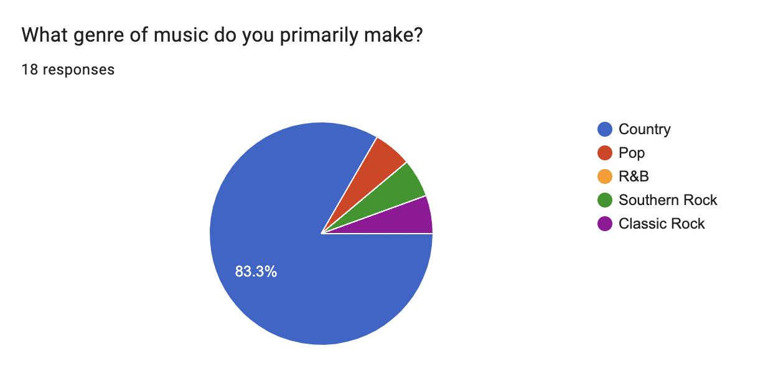
VIM should maintain its targeted marketing and advertising efforts toward country artists, as the data strongly supports the continued relevance of this demographic. According to the AMAze Group's client form, an impressive 83.3% of respondents identified themselves as creators of country music, underscoring the genre's centrality to VIM’s clientele. This high percentage indicates not only a clear demand within the country music sector but also an established alignment between VIM's offerings and the needs of country artists. By continuing to focus on this niche, VIM can reinforce its position as a key player within the country music community, ensuring that its messaging resonates with the core of its customer base and fosters long-term loyalty.

Conclusions
The AMAze Group's findings highlight that VIM’s primary users are individual artists, with fewer managers, publicists, and record labels, indicating the platform's focus on artists seeking direct, personalized promotion. A majority of VIM’s clients discovered the service through word of mouth, emphasizing strong customer satisfaction and community engagement. Most clients choose VIM’s Premium promotion package, demonstrating their commitment to impactful, high-quality campaigns, though there's potential to add custom promotion options to better manage expectations. The data reveals that VIM’s clientele skews older, with a preference for YouTube and Instagram, suggesting these as strategic platforms for outreach. While most clients find VIM’s website intuitive, some reported navigation issues, prompting a recommendation for ongoing improvements. Overall satisfaction is high, with many willing to reuse the service, yet a small portion expressed dissatisfaction, indicating an opportunity for refining customer experience. Furthermore, expanding VIM’s market beyond Nashville and maintaining a focus on country music, a genre central to 83.3% of clients, could enhance the brand reach and foster loyalty.

Branding
The AMAze Group’s next objective was to create new branding guidelines that match Visual Image Marketing’s identity while evolving to match the industry standard. The suggestions are broken down into separate categories: Tagline, Mission Statement, Alternative Logos, and Brand Kit.

Tagline
The AMAze Group voted on a select group of taglines by popular vote, the team selected the following:

Amplifying Independent voices one promotion at a time.

Other contenders included in following:

Your talent, your exposure, your visual image
Your music, your talent, your visual image
Your talent, your music, our visual image
You bring the talent, we bring the camera
You bring the talent, we bring the promotion
Turning talent into charts
Turning your dreams into a visual reality
You visualize the future, we make it a reality
Music, magic, marketing
Music, magic, visual image marketing
Music marketing that turns visuals into reality
Turning independence into influence
Making your music public experience
Your music, your video, our success
Turning your talent into familiar music
Amplifying Independent voices one promotion at a time
Amplifying solo talent through one video at a time
Elevating solo talent
Take your talent to the next level; Amplifying independent voices
Elevate your talent

Having a tagline is important for Visual Image Marketing because the tagline will help to draw people's attention to the company as well as help to differentiate the brand from competitors. Having a tagline will keep the company in people's heads and allow for brand recognition because the slogans work through one's subconscious due to priming which happens in one's brain. The taglines that the AMAze Group came up with for visual image marketing are “Amplifying Independent voices one promotion at a time” and “You bring the talent, we bring the promotion”. Having a tagline for Visual Image Marketing is vital because having a tagline will draw more attention to the brand, especially in comparison to its competitors who lack a tagline. Both taglines are short and catchy as well as relate to what Visual Image Marketing does. Having these in addition to the logo will allow the public to get a better understanding of what Visual Image Marketing does as a company.

Mission Statement
A mission statement is a great way to effectively communicate the values and principles of a company. As this statement gives the purpose and objectives a company has, it can be used to measure performance and ensure accountability.

The AMAze Group’s top Choice is as follows:

“Visual Image Marketing’s mission is to give exposure to independent artists through quality video promotion.”

Additional Options were:

“Visual Image Marketing’s mission is to build international exposure for independent artists through quality video promotion”
“To bring exposure to independent country artists through video airplay”
“Giving independent artists the exposure they need through video promotion.”
“Working to bring you to the spotlight through video promotion that will showcase your talent.”

The AMAze Group believes that these would be good mission statements because they effectively capture the core goals for Visual Image Marketing. They communicate the values and vision for VIM to help provide the core mission of the brand.

Alternative Logos
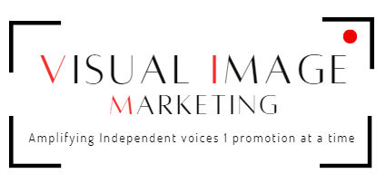
When creating a primary logo, the AMAze Group wanted to incorporate Visual Image Marketing’s past colors and similar design styles. In the first logo, Visual Image Marketing is spelled out in black with the letters V, I, and M in red to highlight Visual Image Marketing’s acronym. The words “Visual Image” are larger than the word “marketing” to balance out the logo and effectively use the space within the camera lens graphic. The camera lens graphics adds a vintage aspect while incorporating the color palette. Finally, in a smaller, secondary font, the tagline is under “Visual Image Marketing” so the viewer reads the company name first and the tagline second.


When creating the secondary logo, the AMAze Group aimed to create a smaller version of the primary logo that could easily be added into smaller areas such as on a social media profile, after sending an email, or on various website tabs. The purpose of the secondary logo is to replace it with the primary logo in places where the primary logo is not as suitable. The AMAze Group created this secondary logo that represents a compact version of the main logo. The same design style, colors, and fonts are used.

Other Designs:

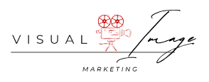
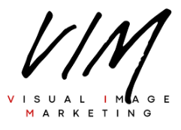

Brand Kit
Colors:
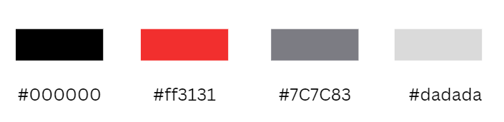
The AMAze Group decided to keep the initial color scheme Visual Image Marketing was working with. The main colors are red and black and gray is a secondary color used in other aspects other than the logo such as the website. According to Adobe, red is a color that stands out and grabs attention. It represents passion, strength, and confidence. Red can bring urgency to a message which has a significant impact on what the reader gains from that message. Additionally, Adobe says that black is a powerful color and adds strength to a message. It can help designs look polished and minimal which is important to logo design. The AMAze Group was able to create a balanced logo with red to prevent an over-serious design. Grey is primarily used as a secondary color that can complement any color. The AMAze Group used small aspects of gray in the website to keep it neutralized so the primary colors could stand out.

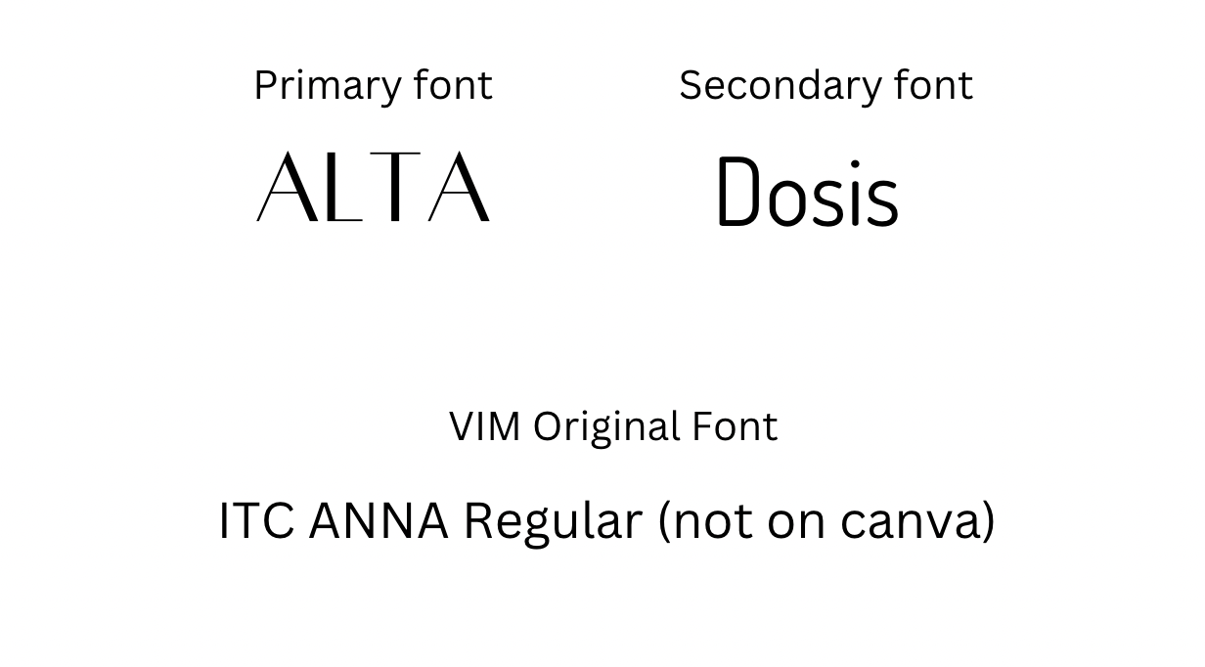
The AMAze Group decided on these fonts to complement the Art Deco aesthetic that was wanted for Visual Image Marketing. These fonts can be used in the logo, website, social media, or anything relating to Visual Image Marketing.

Conclusions
In Conclusion, the AMAze Group believes that making these changes will make VIM appear more appealing to the public eye. Creating these changes to the Logo as well as creating a tagline, sub-logo, and a mission statement will draw people subconsciously to Visual Image Marketing as a company. While some of these changes may appear to be subtle, they will allow Visual Image Marketing to stand out in comparison to their competitors.

Search Engine Optimization and Artificial Intelligence

SEO

Keywords
The AMAze Group recommends focusing on the following keywords and phrases for optimal impact: Music Video Promotion, Independent Artists, Music Video Marketing, Country Music, and Country Music Artists. Using the keyword research tool SEMrush, the AMAze Group identified these terms as having lower keyword difficulty, making them easier to rank. Additional phrases like YouTube Video Promotion and Video Promotion are also beneficial but may be more challenging to rank for due to high search volume.
Given Google’s automated approach to indexing, optimization should not rely solely on custom coding within your website. Instead, the AMAze Group advises prioritizing strategies centered on Google’s ecosystem. Google Search Central explains, “Google is a fully automated search engine that uses programs called crawlers to explore the web constantly, looking for pages to add to our index. You usually don't need to do anything except publish your site on the web. The vast majority of sites listed in our results are found and added automatically as we crawl the web.” Additionally, setting up a Google Business Profile can enhance your site’s search visibility.
To further improve search performance, the AMAze Group suggests incorporating targeted keywords directly into your URL structure—for example, yourwebsite.com/keyword rather than yourwebsite.com/page1234. This approach will enhance your website’s user experience, search engine visibility, and overall performance.

Google Business Suite
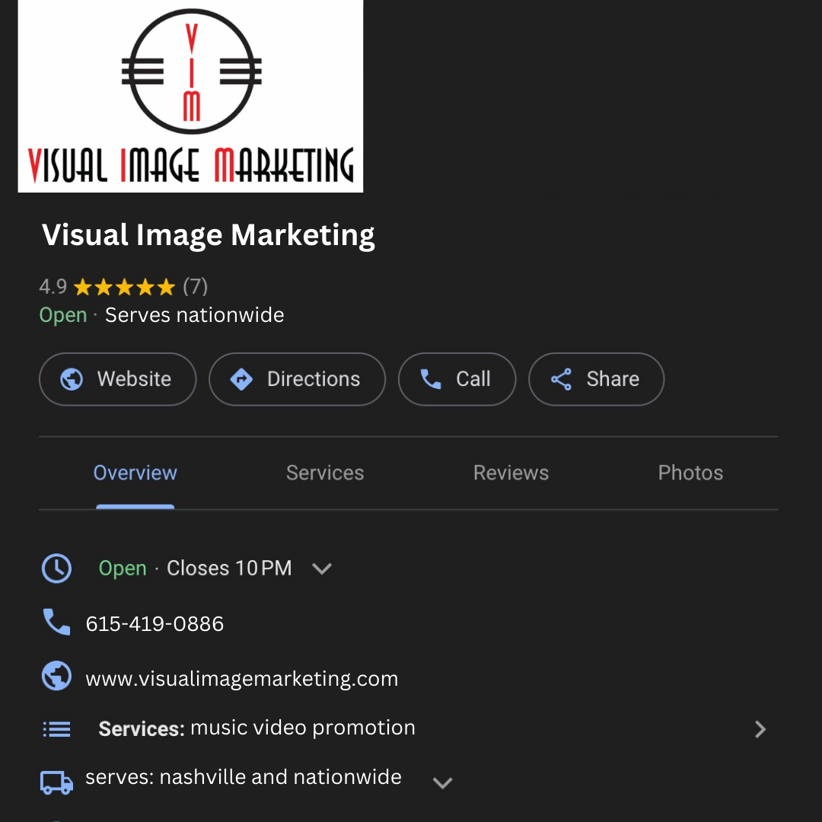
Pictured here is a Mock-up of what your Google profile could look like.

The AMAze Group strongly recommends that Visual Image Marketing (VIM) create a Google Business Profile. Establishing this profile would not only enhance VIM’s online presence but also provide valuable insights into how potential customers engage with the company. A Google Business Profile is a free and straightforward tool that offers numerous benefits, making VIM more accessible to the public. With a Google Business Profile, VIM can track key metrics such as how many people view their listing, where these users are located, and how they interact with the profile (e.g., clicks to the website or calls). Additionally, the profile allows the company to showcase essential business details like photos, videos, social media links, customer testimonials, phone numbers, website links, and more. By regularly updating this information, VIM ensures continued optimization, which is vital for visibility in Google searches. Given that Google holds over 90% of the global search engine market share, a business profile is a crucial element in VIM’s search engine optimization (SEO) strategy. As local searches become increasingly common, having a Google Business Profile will significantly boost VIM's visibility, especially in geographically specific searches in areas like Nashville. Without this profile, VIM risks being excluded from local search results when potential customers look for services in their area. The profile also allows VIM to post updates about upcoming events and promotions, keeping their audience engaged. Customer reviews, whether positive or negative, play a critical role in ranking higher in search results. Responding to reviews demonstrates attentiveness and helps build trust with potential clients. Creating and maintaining an up-to-date Google Business Profile is one of the most effective, free methods for boosting VIM's online presence, improving local SEO, and building customer trust.

To create your Google Business Profile, visit https://www.google.com/business/ and click "Manage Now." Enter your business name and select the appropriate business type. Next, provide a business category, define your service areas, and include your phone number and website URL. The AMAze Group recommends opting in to receive tips and updates on improving your profile for better visibility. To make your profile public, it must be verified; this can be done by entering your billing address. Setting up a business profile will benefit consumers looking to contact VIM, as it allows them to know the best times to reach you. Even if VIM does not have official business hours, listing hours of availability can help attract more customers. You will also be prompted to add a 750-character business description. This is a key opportunity to incorporate essential keywords and business highlights, making your profile more discoverable in search results. Additionally, you can upload photos and videos to visually represent your company, which the AMAze Group highly recommends for better engagement. You can always return to edit or update your profile as needed.

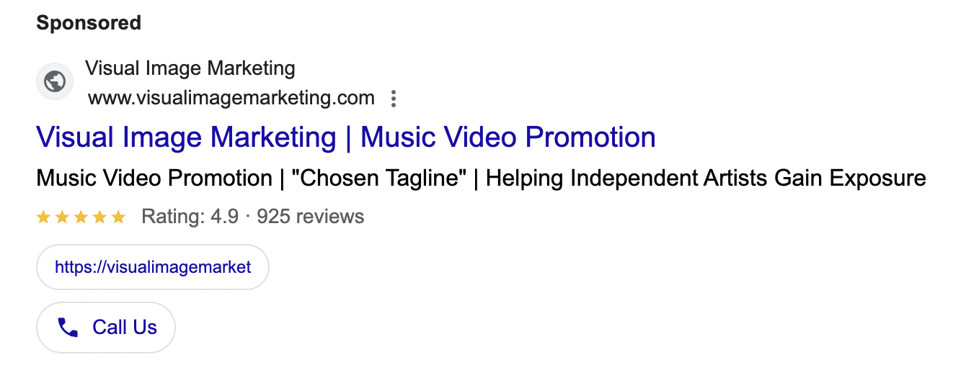
Pictured above is a mock Google ad.
To increase website traffic, enhance brand awareness, and boost your company’s prestige, a well-crafted paid ad is essential. This ad should align closely with the headline, call to action, and offer on your paid search landing page. By maintaining consistency, visitors’ experience from ad click to website landing will feel seamless, clearly communicating your value. To help accomplish this, the AMAze Group included these critical elements in your ad. To create a paid ad, go to https://ads.google.com/ ​​​​ and click “Start Now.” Before launching a paid ad, the AMAze Group suggests creating a Google Business Profile, as this allows most business information to auto-populate. Select “Yes, use info from this business profile” and verify that all information remains accurate throughout setup. When choosing the destination for ad clicks, select your website. You’ll see a preview of your site on both mobile and desktop devices—if it looks good, proceed. For the primary goal, the AMAze Group recommends selecting “Get more website sales or leads.” This choice aligns with generating meaningful engagement with potential clients. The next step involves accepting Google Analytics integration, which provides invaluable insights into visitor behavior, allowing you to measure performance, optimize engagement, and make data-driven decisions.
When writing the ad, maximize the number of headlines and descriptions allowed, as Google will test various combinations to determine the most effective. Keep the “Show a call button in your ad” option selected, as it encourages direct contact. Add relevant images and a logo for brand recognition, followed by strategic keyword selection. Google recommends 7-10 keywords for optimal results, ideally tailored to terms your potential clients are likely searching. The AMAze Group suggests focusing on previously discussed keywords. To target your audience effectively, select “Advertise in specific zip codes, cities, or regions,” expanding your reach geographically without limiting your ad to a single address. Next, decide on a budget. When setting a budget, you’ll see options based on your business needs. Google’s recommended starting point is $9.60 per day, estimated to yield 100-240 clicks monthly, providing a balanced entry level for most businesses. Alternatively, you may set a custom budget that reflects your competitive landscape, with options from $1.50 to $30.70 daily. Finally, review your campaign, enter payment details, and submit. Following these steps ensures your ad aligns with best practices, setting the stage for successful engagement with your audience.

AI Utilization
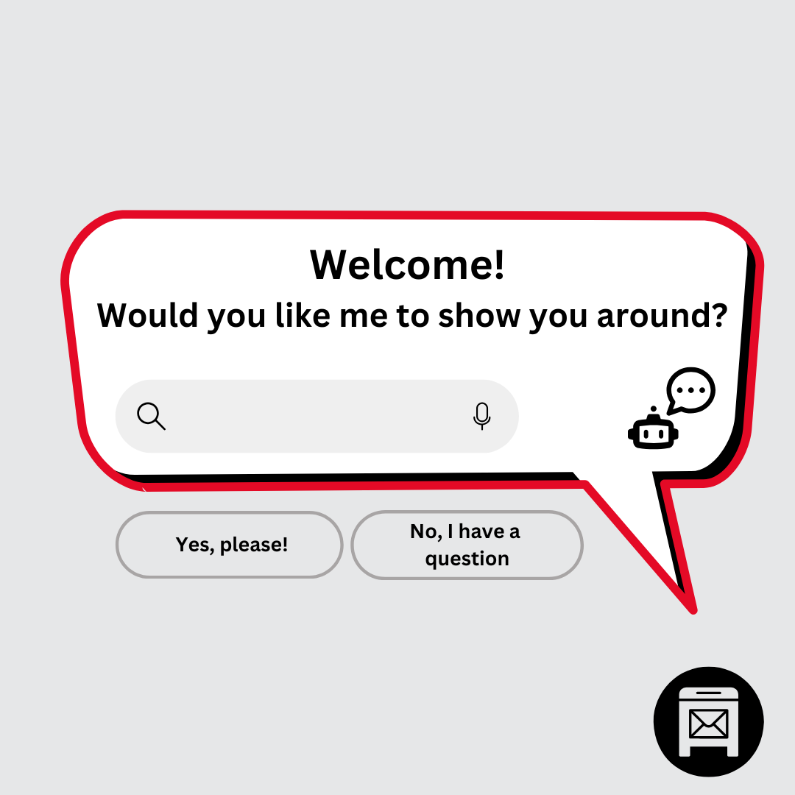
The AMAze Group created a mock-up of a potential AI chatbot that could be used on the website.
One benefit of using an AI chatbot is that people are more likely to inquire and interact with you when they have a chatbox encouraging them to ask you questions. The questions could also help you until you can respond yourself. It improves customer experience and service and also increases engagement.
A chatbot is an artificial intelligence-powered software application designed to simulate human-like conversations through text or voice interactions. For Visual Image Marketing, a chatbot is a perfect fit due to the nature of the business and clientele. As a company specializing in music video promotion for independent country and American artists, VIM deals with a diverse range of clients who may have varying levels of industry knowledge and differing time zones. A chatbot can provide immediate, 24/7 assistance, answering common questions about VIM's services, their extensive experience promoting over 400 music videos, and the wide network of over 65 music video outlets they work with. This constant availability is particularly valuable in the music industry, where artists and managers often work unconventional hours. The chatbot can efficiently handle initial inquiries, educate potential clients about the importance of music video promotion, and highlight VIM's unique selling points, such as their numerical reporting of airplay and their reach into international markets. By automating these initial interactions, VIM can streamline its client acquisition process, allowing it to focus on more complex aspects of strategy and relationship-building. The AMAze Group believes a chatbot aligns well with VIM's forward-thinking approach to visual media, demonstrating their embrace of modern technology in all aspects of their business, from promotion to client communication.
The AMAze Group suggests using a website such as Intercom to create an AI chatbot for AI customer support. Here is a step-by-step to make one on Intercom: Install the Intercom Messenger to engage with customers across channels in real-time, and set up Fin AI Agent to handle queries or pass them to your team as needed. Invite teammates to collaborate efficiently by assigning roles and permissions within Intercom, boosting productivity. Centralize support content in the Knowledge Hub to power Fin AI Agent, Fin AI Copilot, and your Help Center for streamlined, consistent support. Fin AI Agent provides instant customer assistance via Messenger and email, promoting self-service and enhancing customer satisfaction. Meanwhile, Fin AI Copilot serves as an AI assistant for your team, helping them quickly find answers and elevate the customer experience.
Artificial Intelligence could revolutionize Visual Image Marketing's operations by focusing on three very important areas: data-driven campaign optimization, automated performance tracking, and predictive analytics. In terms of campaign optimization, AI could analyze patterns across their extensive portfolio of 400+ music videos to identify which platforms, timing, and promotional strategies work best for different types of artists and music styles - making VIM’s 16-week promotion cycles more targeted and effective. Do not be afraid to ask ChatGPT for ideas. For performance tracking, AI could create real-time, automated reporting systems that monitor video engagement across all 65+ video outlets and international markets, replacing traditional "Heavy, Medium, or Light" notations with detailed numerical analytics and engagement metrics. This would provide clients with more comprehensive insights while saving staff time. Most importantly, predictive analytics could transform how VIM approaches new campaigns by analyzing historical data from successful promotions, identifying emerging trends in country and Americana music videos, and forecasting potential performance metrics for new clients. This would allow VIM to provide data-backed strategies to their clients, from established artists like Dolly Parton to emerging independent performers, which would strengthen VIM’s position as an industry leader in music video promotion while maintaining a personalized, individual approach to each client's needs.

Conclusion
The AMAze Group outlines a strategic approach for Visual Image Marketing (VIM) to strengthen its online presence and customer engagement. By establishing a Google Business Profile, VIM can increase its visibility in local search results, capture essential data on customer interactions, and build trust through customer reviews. This profile allows VIM to share business updates, manage customer feedback, and improve search engine optimization (SEO) with a cost-effective tool, making it easier for local clients to discover and engage with the brand. Adding paid Google ads with targeted keywords and aligning ad content to landing pages can further boost VIM’s website traffic and brand awareness. The ability to target ads by geographic area also enhances VIM’s appeal to local clients and strengthens its reach within specific regions.
Additionally, integrating an AI-powered chatbot, such as Intercom, can improve customer service by providing 24/7 support, answering common questions, and educating potential clients about VIM's services. This automation reduces the burden on VIM and supports customer inquiries around the clock, aligning well with the unique needs of the music industry. The AMAze Group further suggests utilizing AI for campaign optimization and predictive analytics, enabling VIM to analyze performance data, identify trends, and create data-backed strategies for clients. These AI-driven insights would make VIM's 16-week promotional cycles more effective, setting the company apart in the competitive music video promotion landscape and solidifying its reputation as a forward-thinking leader in visual media marketing.

Social Media

Instagram
A good Instagram feed should have a cohesive aesthetic that reflects the brand or personal style, creating a visually appealing experience for followers. Consistency in color palette, tone, and content style helps to establish a recognizable identity and builds a connection with the audience. The magic of color theory can elevate your Instagram feed to new heights! Each color evokes different emotions and messages, creating a powerful visual impact. For instance, red can spark energy and passion, while black adds sophistication and depth. White brings balance and clarity, allowing other colors to shine. By thoughtfully combining colors, you can create a cohesive and visually appealing aesthetic that draws in your audience and strengthens your brand identity. High-quality images, thoughtful composition, and balanced layouts draw attention and keep the feed from looking cluttered or disorganized. Strategically planning and spacing out different types of content — like photos, graphics, quotes, and videos — maintains visual interest and encourages engagement. Captions should be authentic, aligning with the feed's tone, and include relevant hashtags and calls to action to boost reach and interaction.
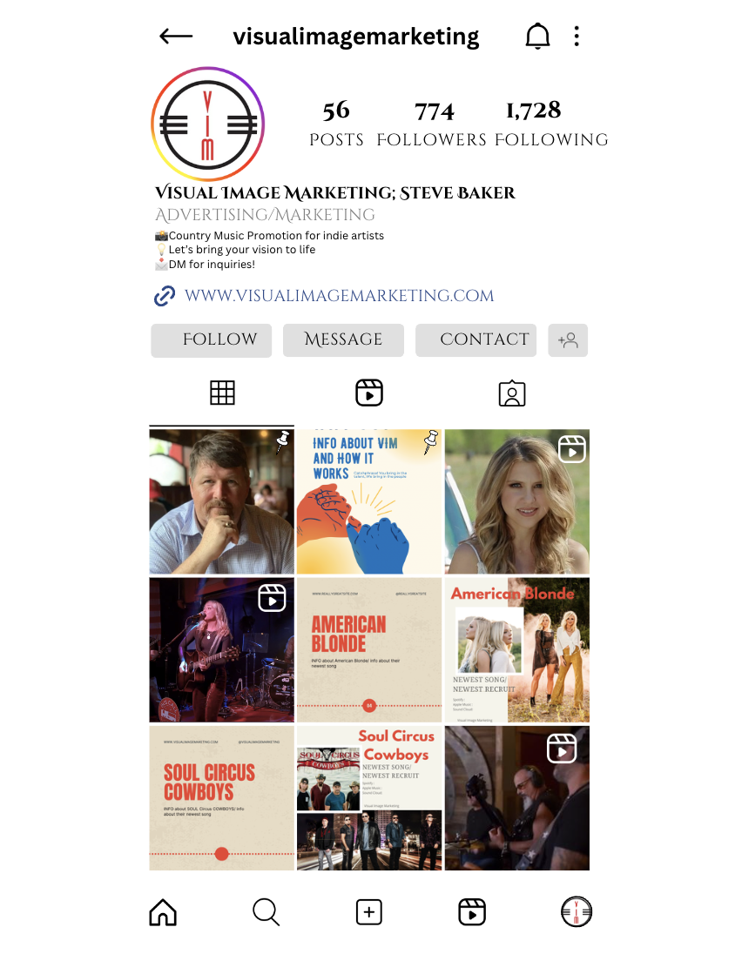
Maintaining a consistent Instagram feed not only looks visually appealing but also makes it easier for potential customers and followers to engage with your content. By incorporating a cohesive color scheme, such as red and neutral tones, The AMAze Group ensures the feed aligns seamlessly with the profile picture, creating a harmonious overall aesthetic. Regularly updating your feed with fresh content is also crucial for maintaining interest. Consistency in posting schedules helps keep your audience engaged and encourages them to return to your profile for new updates.
Consistently posting on Instagram Stories is an effective strategy to ensure your brand remains visible on your followers' feeds. Stories provide a unique opportunity for real-time engagement, allowing you to share updates, promotions, events, and behind-the-scenes content that keeps your audience informed and connected to your brand. Putting limited-time promotions or flash sales through Stories encourages immediate action, making people curious and click to your profile or website.


In this Instagram story concept, there is a feature on Instagram to add links to stories. By adding a link to, for example, The American Blonde’s Christmas music videos, viewers will click on the mystery present box because this element of mystery taps into viewers’ natural impulse and curiosity to uncover hidden content. This is a fun and engaging way to promote music videos.

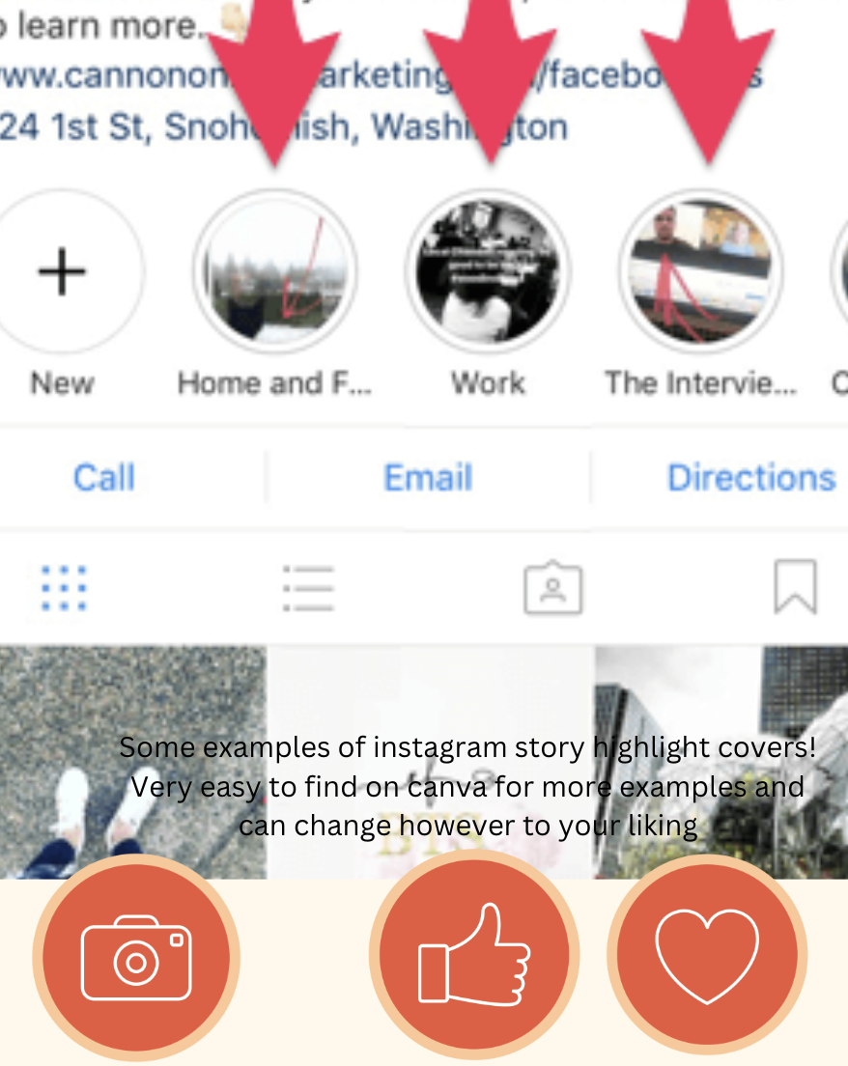
The AMAze Group suggests utilizing highlights to categorize the different themes and topics that are important information posted on your stories. Adding a customer feedback highlight is a great way to build credibility and trust among potential customers, demonstrating social proof. Having customer feedback as a highlight will make it easy for new customers to read about you. To create a highlight, simply create a story post and save it to your highlights so it will remain at the top of the VIM page. Highlight sections could include “Contact Us”, “Services”, “Christmas Video Promotion”, “About Us”, “Customer Feedback”, etc. Each section would include story posts saved to the highlight sections for customers or potential customers to quickly see.

Meta Suite
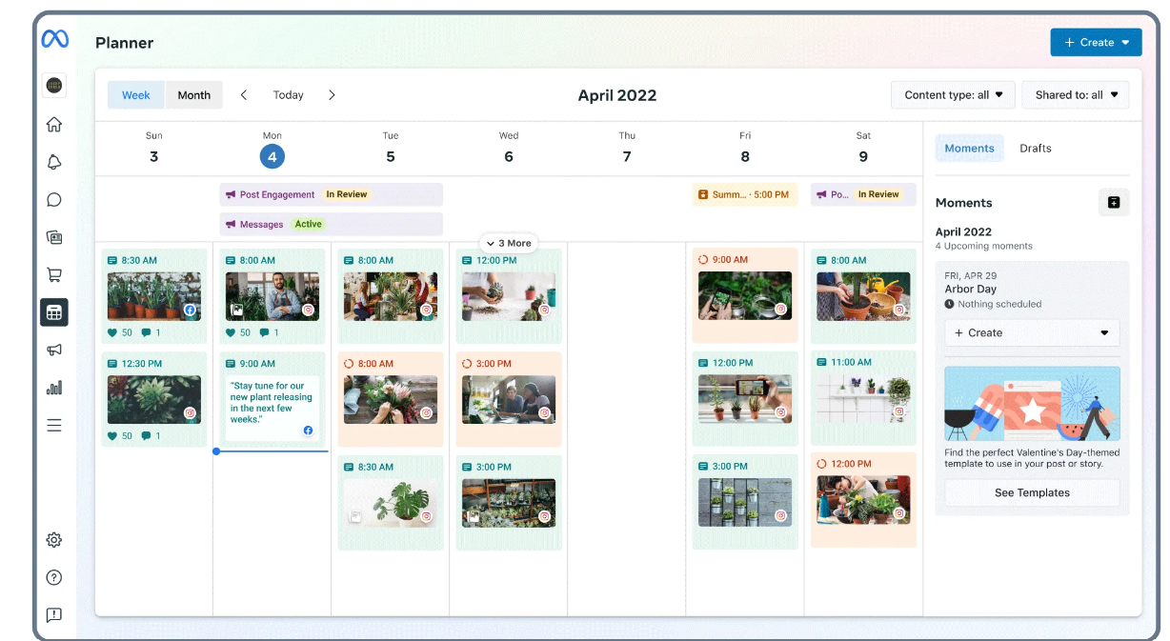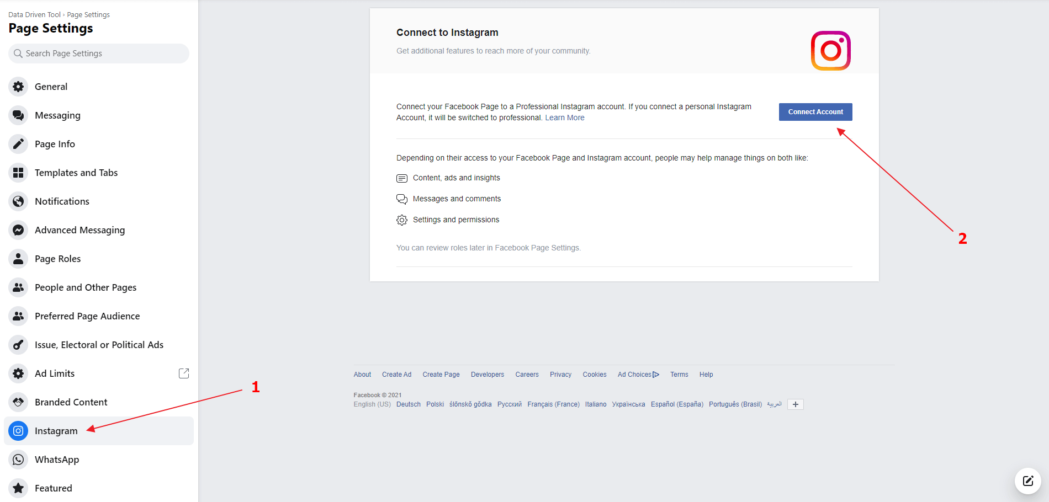

The AMAze Group suggests syncing Facebook and Instagram to have cohesiveness among channels and ease of consistent content creation. Over the past couple of months, Visual Image Marketing’s Instagram followers have fluctuated between 773 and 775. Social media following should consistently increase to drive business and awareness for VIM. The AMAze Group has discovered that no new content has been created since July for Instagram, so getting into a consistent posting schedule could tremendously increase VIM’s following. It is recommended that you post on Instagram and Facebook 1-2 times a day and post 2 stories per day. This posting schedule should result in a consistent increase in followers. Stories, posts, and Reels can all be linked, so you do not have to create different content for each platform. The AMAze Group wants to emphasize that quality content is much more important than quantity of content, so if 1-2 posts are not manageable, find a posting schedule that you can stay consistent with. You can also schedule out content with Meta Suite so that you do not have to work on social media daily. Utilizing the Meta Planner will result in ease of ensuring consistent content is posted.

LinkedIn
Making a new LinkedIn profile solely for Visual Image Marketing would promote engagement by leveraging several strategies that foster interaction and build a professional community. This can be done by regularly sharing valuable, relevant content—such as industry insights, company news, or thought leadership articles. Encouraging conversations by asking questions, responding to comments, and engaging with followers also builds rapport and increases visibility. Additionally, using LinkedIn’s features like polls, live videos, and articles can further engage the audience. You can also boost engagement by participating in industry-related groups, joining conversations, and networking with other professionals. Employee advocacy programs, where staff share company content on their personal LinkedIn profiles, can expand reach and credibility while running targeted ad campaigns that can increase visibility and generate leads. For example, Spotify has its own LinkedIn profile, and they engage in other posts to promote its engagement.

YouTube
Utilizing YouTube Shorts to effectively promote music videos creates eye-catching, engaging content that showcases the unique style of visual image marketing. Crafting compelling 15-60 second clips highlights the catchiest parts of songs, along with promoting visually dynamic scenes from music videos. Incorporating popular trends, challenges, or themes relevant to a specific genre can help tap into existing audiences. Additionally, you could share behind-the-scenes footage, quick tutorials into the music creation process, or personal anecdotes that connect with viewers. Encouraging viewers to interact—like asking for their favorite lyrics or song interpretations—will help foster a community feel. Consistently posting Shorts not only keeps content fresh but also increases the likelihood of being featured in YouTube's recommendations, helping reach a wider audience and drive traffic to his full-length music videos.

TikTok/Reels
Making Instagram Reels or TikToks that can be posted on both platforms will save time as well as boost engagement. Posts on TikTok that get the most engagement typically feature a combination of trending content, creativity, and relatability. Videos that align with popular challenges, use trending sounds or hashtags, and showcase unique or entertaining content tend to go more viral. Short, visually appealing videos with quick transitions, humor, or emotional appeal also resonate well with audiences. Additionally, posts that encourage interaction, such as asking questions or inviting users to participate in a trend, often see higher engagement. For example, making a video with a short clip from certain music videos would be a way to reach more viewers. Another example of a video to post would be a behind-the-scenes of the music video. A platform you can use to edit videos is CapCut. CapCut is a free, all-in-one video editing app developed by ByteDance, the creators of TikTok. It offers a range of user-friendly tools, allowing users to easily edit videos with features like trimming, splitting, and merging clips, adding music, text, filters, transitions, and special effects. CapCut also includes advanced options like speed adjustments, keyframe animation, and background removal. Its simple interface makes it popular for creating engaging social media content, especially for platforms like TikTok and Instagram. The app is designed for both beginners and experienced editors looking to produce high-quality videos on mobile devices.

Conclusions
In conclusion, a well-curated Instagram feed is essential for building a recognizable brand identity and fostering a meaningful connection with followers. Consistency in color schemes, high-quality imagery, and balanced content organization are key to creating an appealing aesthetic that draws in viewers. By strategically integrating elements like Instagram Stories and Highlights, brands can engage audiences in real time and showcase important content, such as customer feedback and promotional videos, in an accessible way. Synchronizing platforms through tools like Meta Suite allows for a cohesive approach across Instagram and Facebook, maximizing reach and engagement without compromising content quality. Additionally, leveraging YouTube Shorts, LinkedIn, TikTok, and Instagram Reels provides opportunities for cross-platform promotion, expanding visibility and community engagement. Overall, a thoughtful, organized approach to social media content creation not only increases brand awareness but also establishes a stronger connection with current and potential followers.

Website

Home
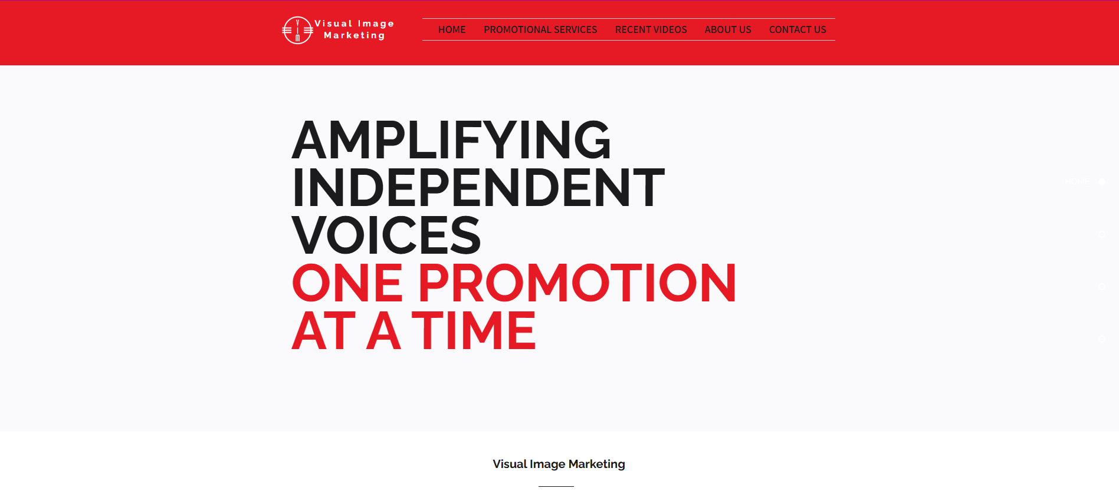
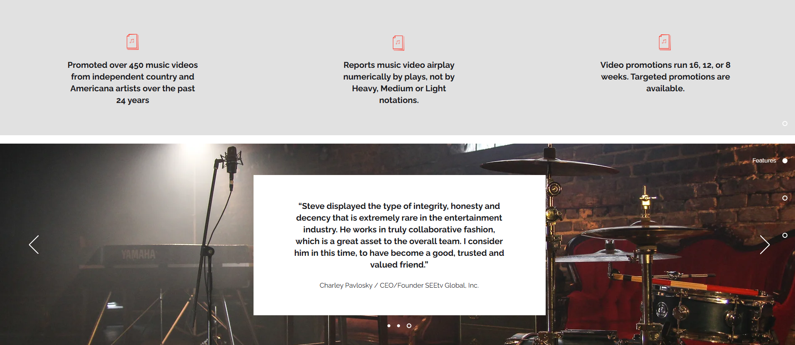

The AMAze Group focused on enhancing the website’s branding by retaining the original colors from Steve’s logo and previous website while infusing them with a modern, vibrant touch to create a more dynamic visitor experience. A key priority was incorporating more red to create a bold, professional aesthetic that not only grabs attention but conveys energy and strength.
To convey Steve’s mission and make a memorable first impression, the branding team crafted a standout tagline: “Amplifying Independent Voices, One Promotion at a Time.” Displayed prominently in bold, larger font, this tagline immediately draws attention, reflecting Steve’s dedication to supporting independent artists. The combination of red and black in the tagline emphasizes passion, sophistication, and professionalism—qualities that underscore the company’s commitment to giving independent voices the platform they deserve.
As visitors scroll down the homepage, they encounter three key points that define Visual Image Marketing’s service strengths: expertise, proven results, and a commitment to client growth. These points are presented in a visually engaging format, ensuring visitors can quickly grasp the scope of services and the impact Steve has on his clients’ careers. This section helps visitors understand why Visual Image Marketing is a trusted leader in video promotion.
The bottom of the homepage features an image of a music studio, capturing the creative essence of Visual Image Marketing and resonating with potential clients. Just above this image are multiple client testimonials, strategically placed to showcase positive experiences and build trust. These testimonials reveal the tangible outcomes clients have achieved with Steve’s support. From major deals and national tours to substantial boosts in visibility, these stories bring Steve’s work to life, allowing visitors to see real examples of his clients’ achievements. This section not only builds trust but also inspires potential clients to envision similar success through Steve’s services.
The layout of the home page balances vibrant visuals, clear messaging, and strategic use of color to create an inviting, impactful homepage that engages visitors and guides them to explore further.

Promotional Services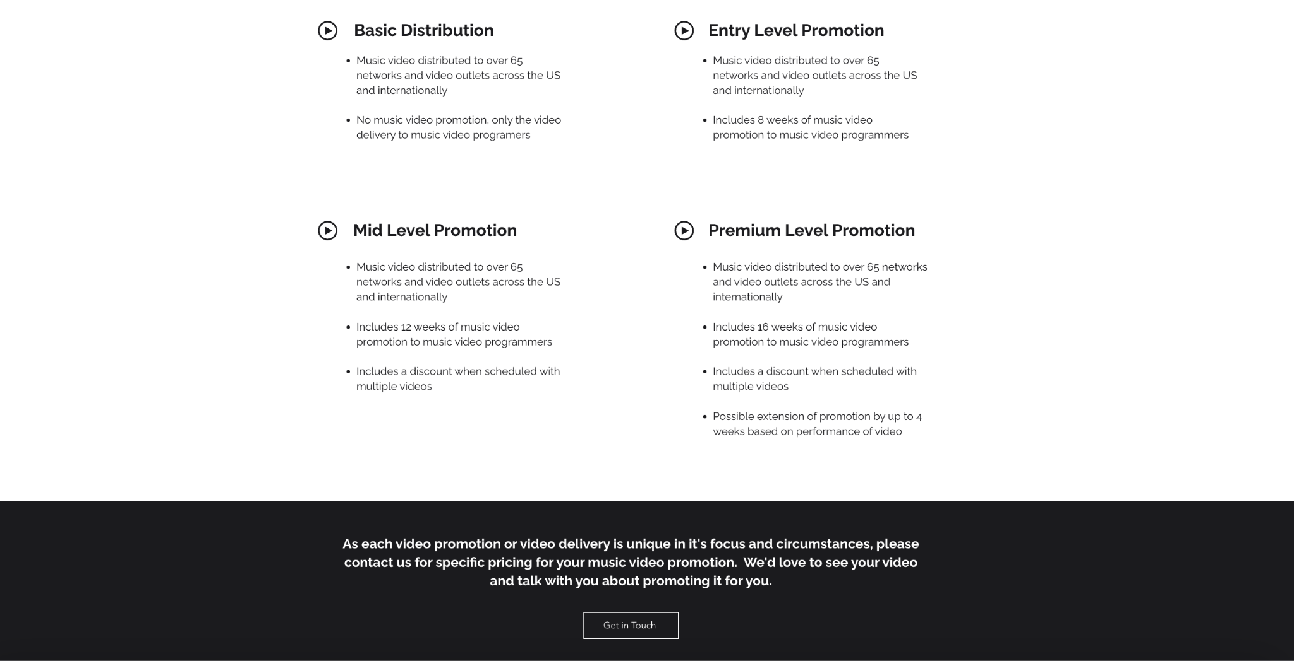

To make it simple and engaging for customers to select the right video promotion package, the AMAze Group designed each tier—Basic, Entry, Mid, and Premium—to be both visually clear and easy to understand. Each level is showcased with concise descriptions, using straightforward language that outlines the benefits and features specific to each package, so clients can quickly assess which level best suits their goals and budget.
The AMAze Group broke down each package in a table format that presents each service level side by side, allowing users to immediately compare key elements such as distribution scope, promotional duration, and exclusive benefits. For example:
- Basic Level is outlined with core distribution features, clearly labeled as a delivery-only option.
- Entry, Mid, and Premium Levels highlight their promotion lengths (8, 12, and 16 weeks, respectively), with additional perks like discounts for multiple videos and potential campaign extensions reserved for Premium displayed prominently.
Each tier includes short, engaging descriptions that capture the unique value of that level, helping clients visualize what they’re receiving and why it may be beneficial. This format clarifies the purpose of each package, from straightforward distribution to extensive promotional campaigns, making it clear how each tier supports different goals—whether it’s a budget-friendly boost or a full-scale campaign.
To ensure a smooth and engaging experience, the AMAze Group added a prominent “Contact Us” button at the bottom of the page, providing a quick path for customers to reach out for specific details or custom pricing. This ease of access encourages immediate action, allowing potential clients to engage with Steve directly, ask questions, or secure a personalized plan that fits their vision.
In sum, this well-organized, engaging, and visually appealing layout enhances user understanding, encourages informed decision-making, and streamlines the path to connect with Steve for further guidance. This clarity and usability are designed to build trust and empower clients to confidently choose the promotion tier that will best elevate their music videos.

Christmas Video Promotion
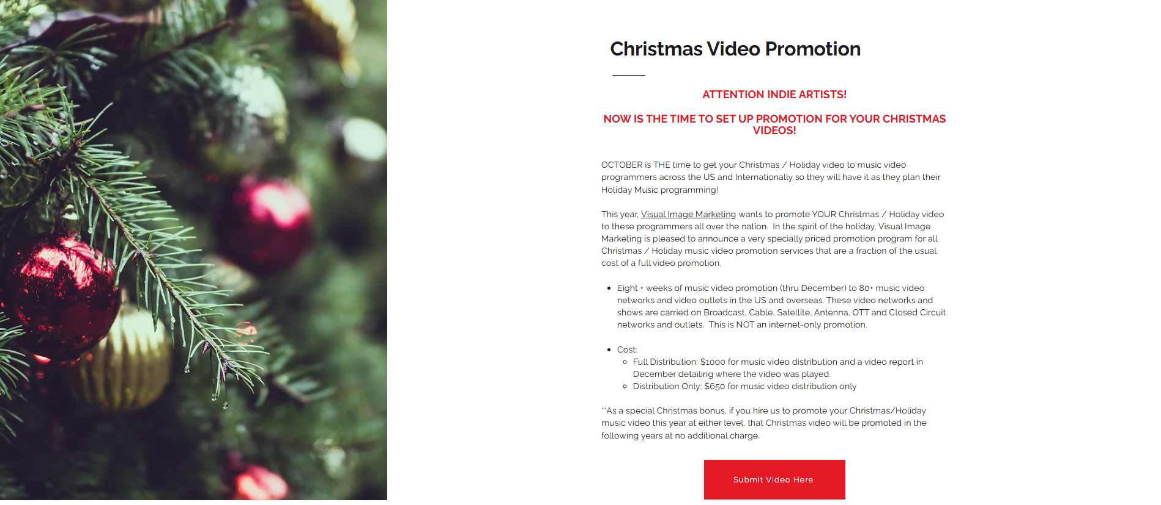

To meet the unique needs of holiday promotions, the AMAze Group developed a dedicated “Christmas Video Promotion” section within the “Video Promotion” page. This specialized page allows clients seeking seasonal video promotion to quickly and seamlessly find the services they need for holiday campaigns.
The Christmas Video Promotion page is thoughtfully designed to be welcoming and inclusive, featuring a festive image of a tree decorated with ornaments that captures the warmth and joy of all winter holidays—not just Christmas. This subtle, universal visual invites clients of all backgrounds and creates a sense of connection, aligning with the seasonal spirit while resonating with a diverse audience. The dedicated holiday video promotion section is designed to help clients capture the magic of the season, offering tailored promotional strategies that enhance holiday visibility and engage audiences. This focused page combines festive visuals, clear navigation, and easy contact options to create an inviting, efficient experience that empowers clients to bring their holiday video visions to life.

Recent Videos
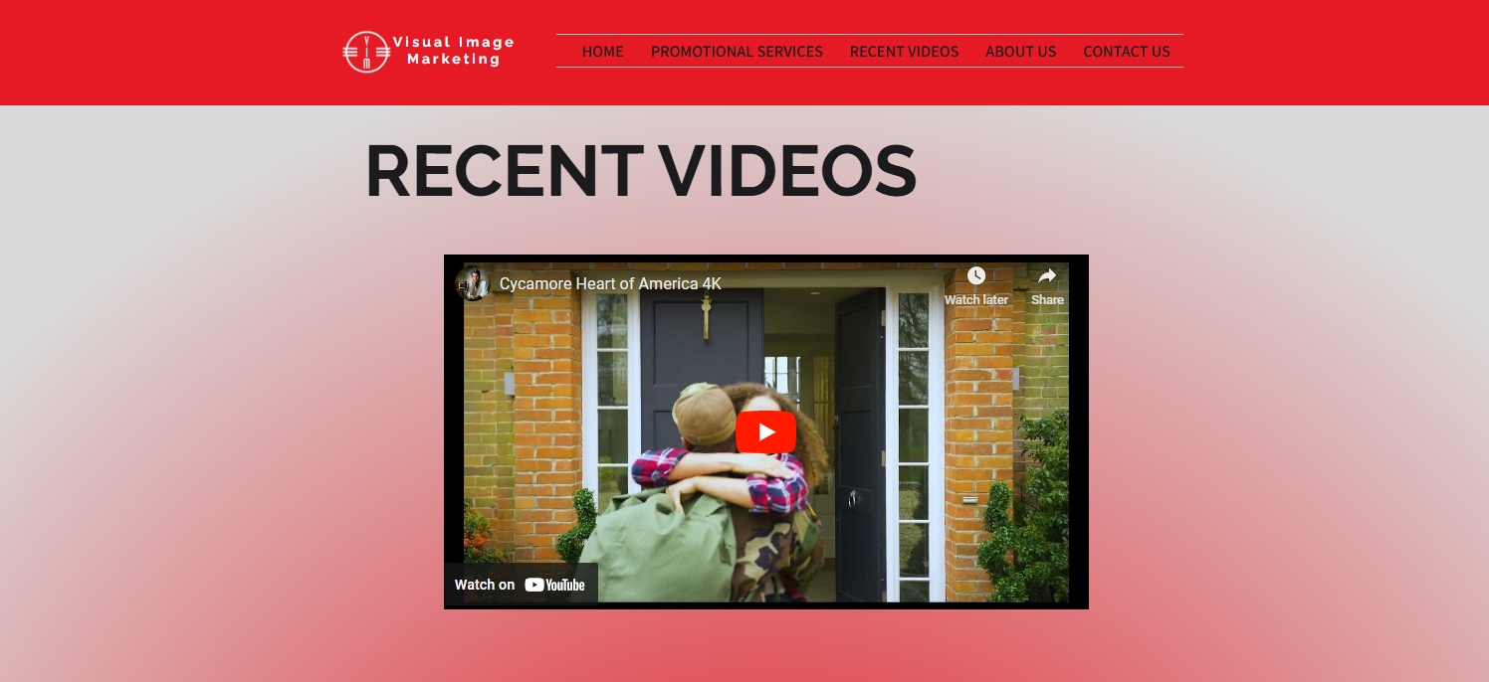

The “Recent Videos” page offers a curated selection of recent projects that highlight the quality and diversity of Visual Image Marketing’s work. This focused approach provides a visually appealing, uncluttered experience, allowing each video to stand out and make a lasting impression on potential clients. By showcasing a range of video styles and successful promotions, this page quickly demonstrates the impact Steve’s promotional services have had, helping clients understand the tangible benefits of partnering with him.
Each video on this page has been chosen to represent different genres and project types, showcasing the breadth of Steve’s expertise. This careful selection allows visitors to immediately see the quality and variety of recent work, providing a snapshot of Steve’s success stories. With each video given space to shine, potential clients can enjoy a seamless viewing experience that highlights the creative potential Visual Image Marketing can bring to their projects.
Seeing these videos inspires a connection, allowing potential clients to envision their work achieving similar visibility and growth. As they view past client successes, they can more easily imagine the positive impact Steve’s services could have on their projects. This connection fosters confidence, encouraging new clients to see Visual Image Marketing as the trusted partner to advance their unique visions.
By focusing on recent successes, the “Recent Videos” page reinforces the credibility of Visual Image Marketing. The carefully chosen examples not only highlight Steve’s proven results but also communicate the real, tangible growth that comes from his promotional expertise. This page stands as a testament to the quality, creativity, and impactful reach Visual Image Marketing offers to clients ready to elevate their projects.

About Us
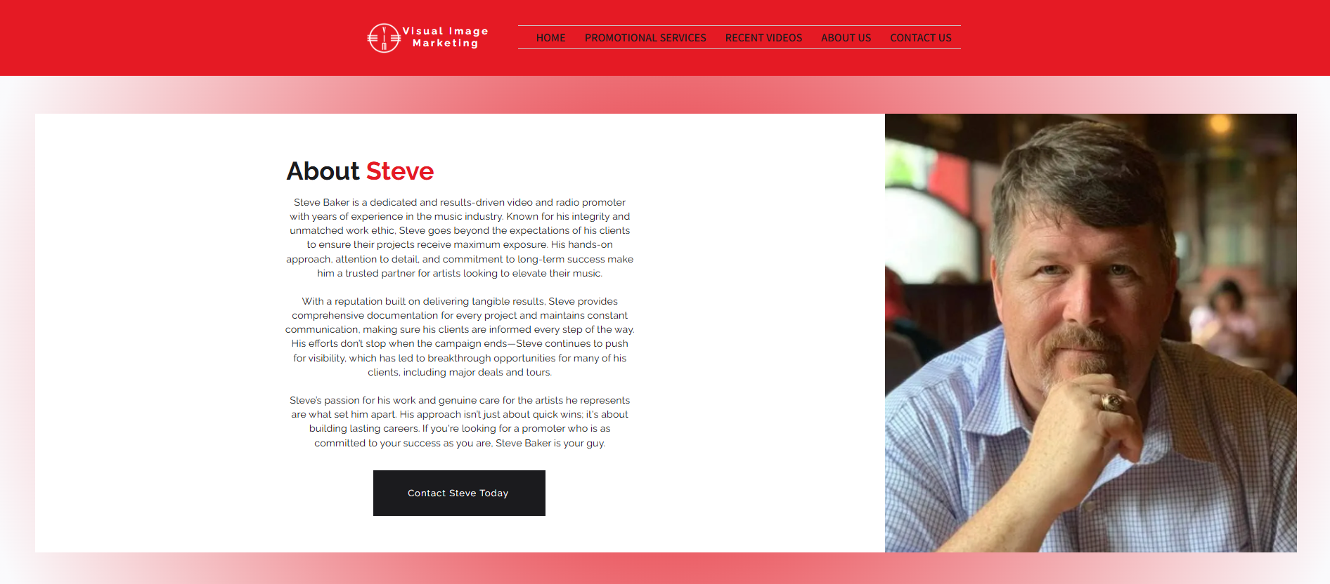

The reimagined "About Us" page for Visual Image Marketing offers a detailed view of Steve Baker’s expertise, dedication, and approach to music video promotion. Through the AMAze Group’s revamp, this page now highlights Steve’s integrity, strong work ethic, and hands-on approach, creating an inviting profile that resonates with potential clients seeking a trusted, results-driven partner.
This page emphasizes Steve’s commitment to supporting clients beyond the initial promotion. By showcasing his dedication to ongoing success, the “About Us” section illustrates how Steve’s work extends past campaign deadlines, helping clients achieve sustained visibility and growth. His role as a trusted partner in each project reinforces his genuine passion for elevating artists’ careers and making a long-term impact.
At the bottom of the page, a prominent “Contact Us” button seamlessly links to the website’s contact section, streamlining the experience for potential clients who are ready to connect. This feature enhances accessibility, making it easy for clients to take the first step toward working with Steve.
This revamped “About Us” page captures the professionalism, expertise, and genuine care Steve Baker brings to each project, positioning Visual Image Marketing as a reliable, passionate partner for artists and brands looking to elevate their video promotions.

Contact Us
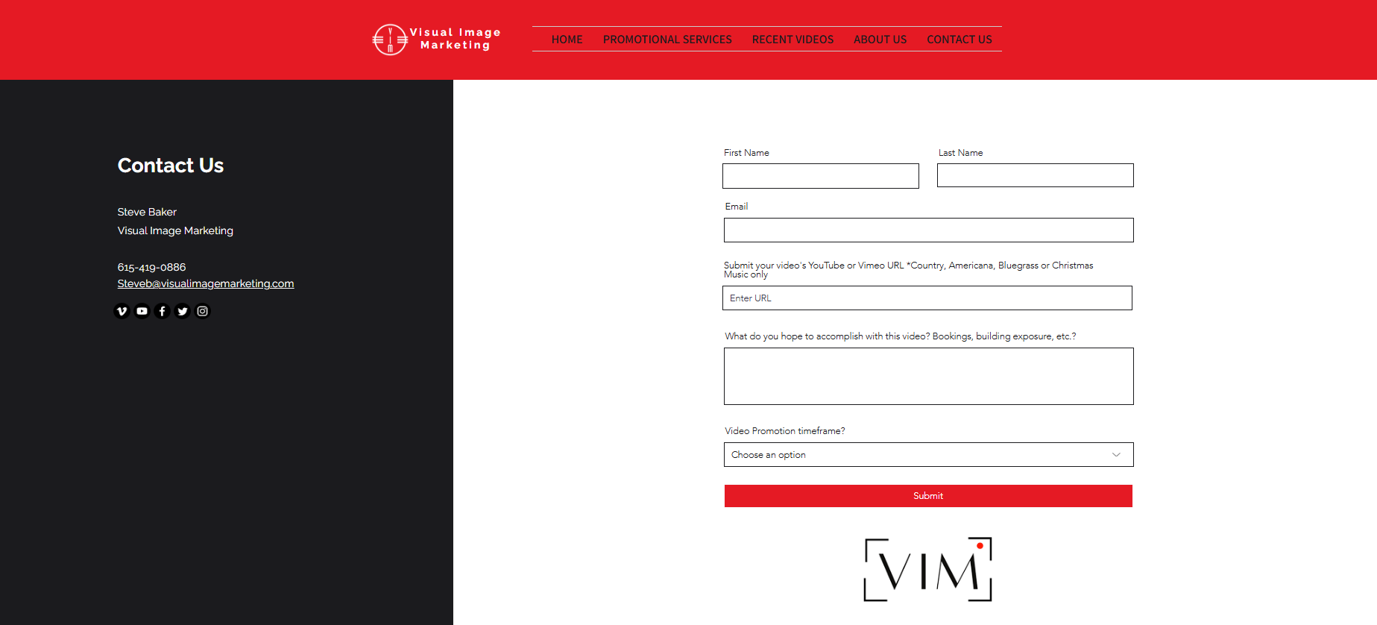

The AMAze Group designed the “Contact Us” page to be a user-friendly gateway for clients to connect directly with Steve Baker and Visual Image Marketing. A streamlined, accessible form allows visitors to quickly submit their name, contact information, and video details, making the outreach process efficient and straightforward. This clear, concise format eliminates any guesswork, ensuring potential clients feel confident and ready to start a conversation with Steve.
To the left of the contact form, Steve’s contact information is presented in a clean, well-organized layout. This section allows potential clients with questions or specific inquiries to easily locate his details, fostering an approachable and responsive image for Visual Image Marketing. By separating this contact information from the form, the page is structured to accommodate both immediate outreach and detailed inquiries.
For added convenience and connection, the AMAze Group incorporated links to Steve’s social media profiles, providing visitors with modern options to engage through their preferred platforms. These links enable clients to follow Visual Image Marketing’s updates and success stories on social media, creating a bridge for ongoing interaction and building brand awareness in the digital space.
This “Contact Us” page balances simplicity, clarity, and connectivity, allowing clients to reach out effortlessly while also staying engaged with Steve’s work and updates. It’s an inviting, modern approach that encourages potential clients to take the first step toward a successful video promotion partnership.

Overall Findings

The AMAze Group thanks Visual Image Marketing for allowing them to assist with updating and helping to grow the brand further. The AMAze Group hopes that the external competitor research, website, social media audits, search engine optimization and AI, and branding and logo marketing materials will help VIM attract and gain more opportunities for music promotion within and around Nashville. Many of the elements included in this deliverable can serve as a basis for VIM to attract new clients and grow socials with modernized website designs and innovative logos.
Lastly, the AMAze Group would like to thank Visual Image Marketing for allowing the AMAze Group the opportunity to work on this project. This project has been conducive to teaching the students more about marketing techniques and growing as marketing professionals. The group is looking forward to seeing the success of Visual Image Marketing and how they continue to grow as a brand. The AMAze Group hopes this project is beneficial for the future growth of this brand.

Bibliography
A Guide to Color Meaning | Adobe, www.adobe.com/creativecloud/design/discover/color-meaning.html. Accessed 4 Nov. 2024.
Viswanathan, Neeraja. “How Your Instagram Feed Can Help Your Brand Succeed.” Manychat Blog, 24 May 2022, manychat.com/blog/instagram-feed-brand/.
“Meta Business Suite Content Planner Lesson.” Meta for Business, 2022, www.facebook.com/business/learn/lessons/meta-business-suite-planner. Accessed 5 Nov. 2024.
Instagram, See. “Scott Social.” Scott Social, 27 May 2024, www.scottsocialmarketing.com/blog/how-to-see-instagram-engagement-and-track-the-results. Accessed 5 Nov. 2024.
Chapman, Cameron. “Color Theory for Designers, Part 1: The Meaning of Color.” Smashing Magazine, 2021, www.smashingmagazine.com/2010/01/color-theory-for-designers-part-1-the-meaning-of-color/.
Ackerman, Aliza. “A Guide to Color Meaning | Adobe.” Www.adobe.com, 2023, www.adobe.com/creativecloud/design/discover/color-meaning.html.
“Custom vs. Productized Services: How to Decide at Your Agency.” Sakas & Company, 22 Feb.
2024, sakasandcompany.com/custom-vs-productized-services/.
“Social Media Fact Sheet.” Pew Research Center, Pew Research Center, 31 Jan. 2024,
www.pewresearch.org/internet/fact-sheet/social-media/?tabItem=5b319c90-7363-4881-8
e6f-f98925683a2f.
“10 Benefits of Having a Google Business Profile.” SCORE,
www.score.org/greaterphoenix/resource/blog-post/10-benefits-having-a-google-business
-profile#:~:text=Here%20are%2010%20Benefits%20of%20having%20a%20Google%20
Business%20Profile&text=Provides%20a%20great%20first%20impression,up%20to%20
35%25%20more%20revenue. Accessed 4 Nov. 2024.
14, Published: Aug. “How Much Does Google Ads Cost in 2024?” WebFX, 15 Oct. 2024, www.webfx.com/blog/ppc/much-cost-advertise-google-adwords/#:~:text=Google%20Ads%20costs%20%24100%20%E2%80%93%20%2410%2C000%20per%20month%20.
“15 Online Review Statistics (2024).” Backlinko, 28 Aug. 2024, backlinko.com/online-review-stats.
“Chatbot vs. Live Chat: Pros and Cons for Businesses.” Mailchimp, mailchimp.com/resources/chatbot-vs-live-chat/?igaag=154664726859&igaat=&igacm=20637339549&igacr=687230856184&igakw=&igamt=&igant=g&ds_c=DEPT_AOC_Google_Search_US_EN_NB_Acquire_Broad_DSA-Rsrc_US&ds_kids=p78250621731&ds_a_lid=dsa-2227026702184&ds_cid=71700000115207178&ds_agid=58700008574686663&gad_source=1&gclid=Cj0KCQjwmOm3BhC8ARIsAOSbapXjR6twDuhliGItQ88Ja0HtFtBxQomsxJzoooEs1zASP2svpBTfW_QaAuBoEALw_wcB&gclsrc=aw.ds. Accessed 21 Oct. 2024.
“Get Listed on Google.” Google Business Profile, Google, www.google.com/business/. Accessed 28 Oct. 2024.
Google Search Central. “Search Engine Optimization (SEO) Starter Guide.” Google, Google, developers.google.com/search/docs/fundamentals/seo-starter-guide. Accessed 21 Oct. 2024.
Leah. “Build an AI Chatbot for Your Website: 5 Steps.” Userlike Live Chat, Userlike, 13 Mar. 2024, www.userlike.com/en/blog/chatbot-for-website#:~:text=Website%20chatbots%20can%20help%20drive,to%20streamline%20the%20recruitment%20process.
“Live Chat Software: INTERCOM.” Making Internet Business Personal, www.intercom.com/drlp/nb-live-chat?utm_source=google&utm_medium=sem&utm_campaign=19688136635&utm_term=live+chat+on+website&utm_ad_collection=148585375600&utm_ad=697382153212&gad_source=1&gclid=Cj0KCQjw99e4BhDiARIsAISE7P_a8U6B5QUHQp3unwxGvvoXIJT88xRsvY5mCCTTeEZrSnFkHuzJQcUaAod_EALw_wcB. Accessed 14 Oct. 2024.
Ltd, Innovation Visual. “Why Is Google Business Profile Important for Your Business?” Leading Digital Marketing Agency in Surrey, www.innovationvisual.com/knowledge/why-is-google-business-profile-important-for-your-business. Accessed 21 Oct. 2024.

Survey

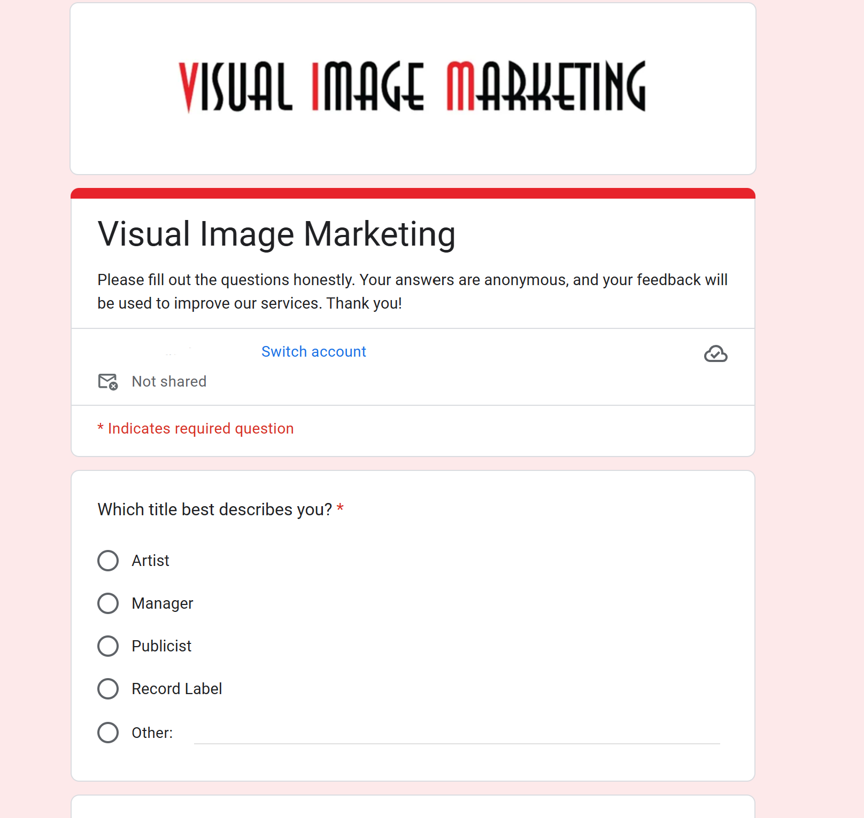
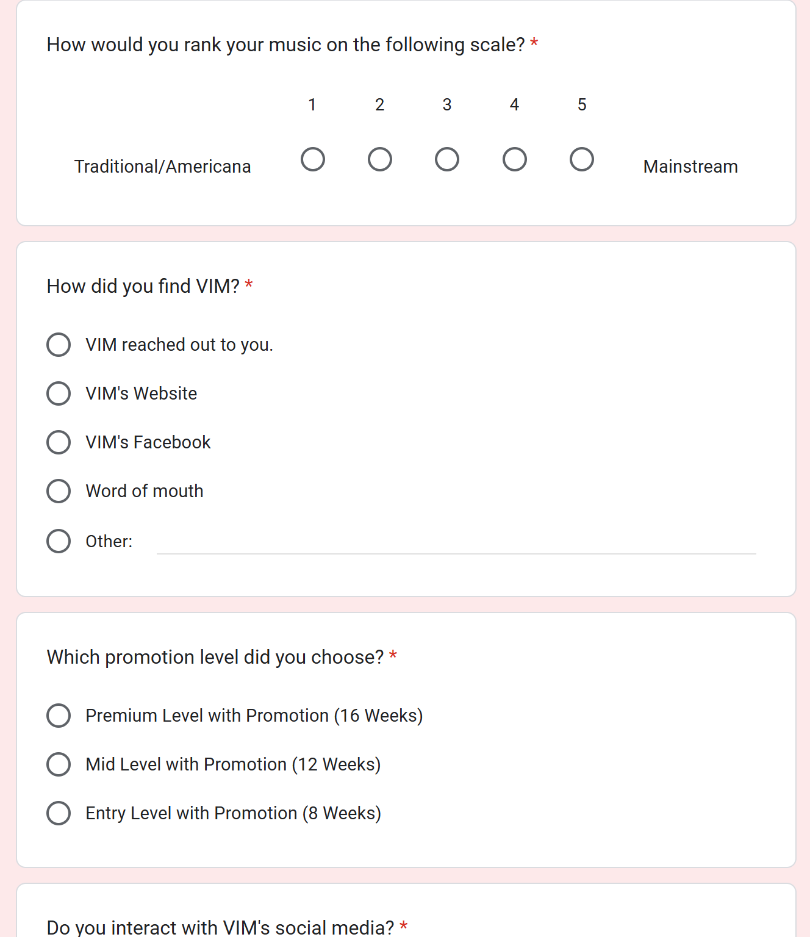
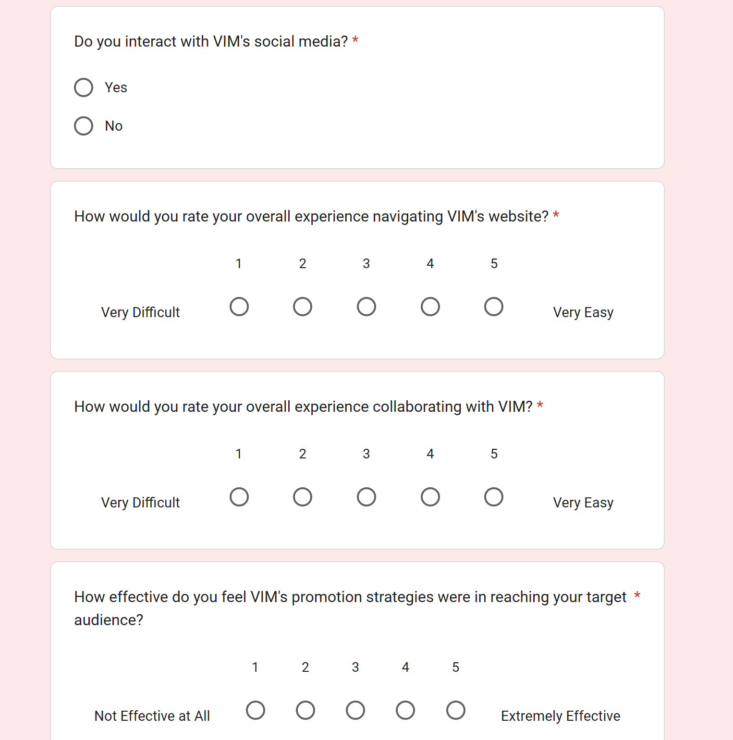
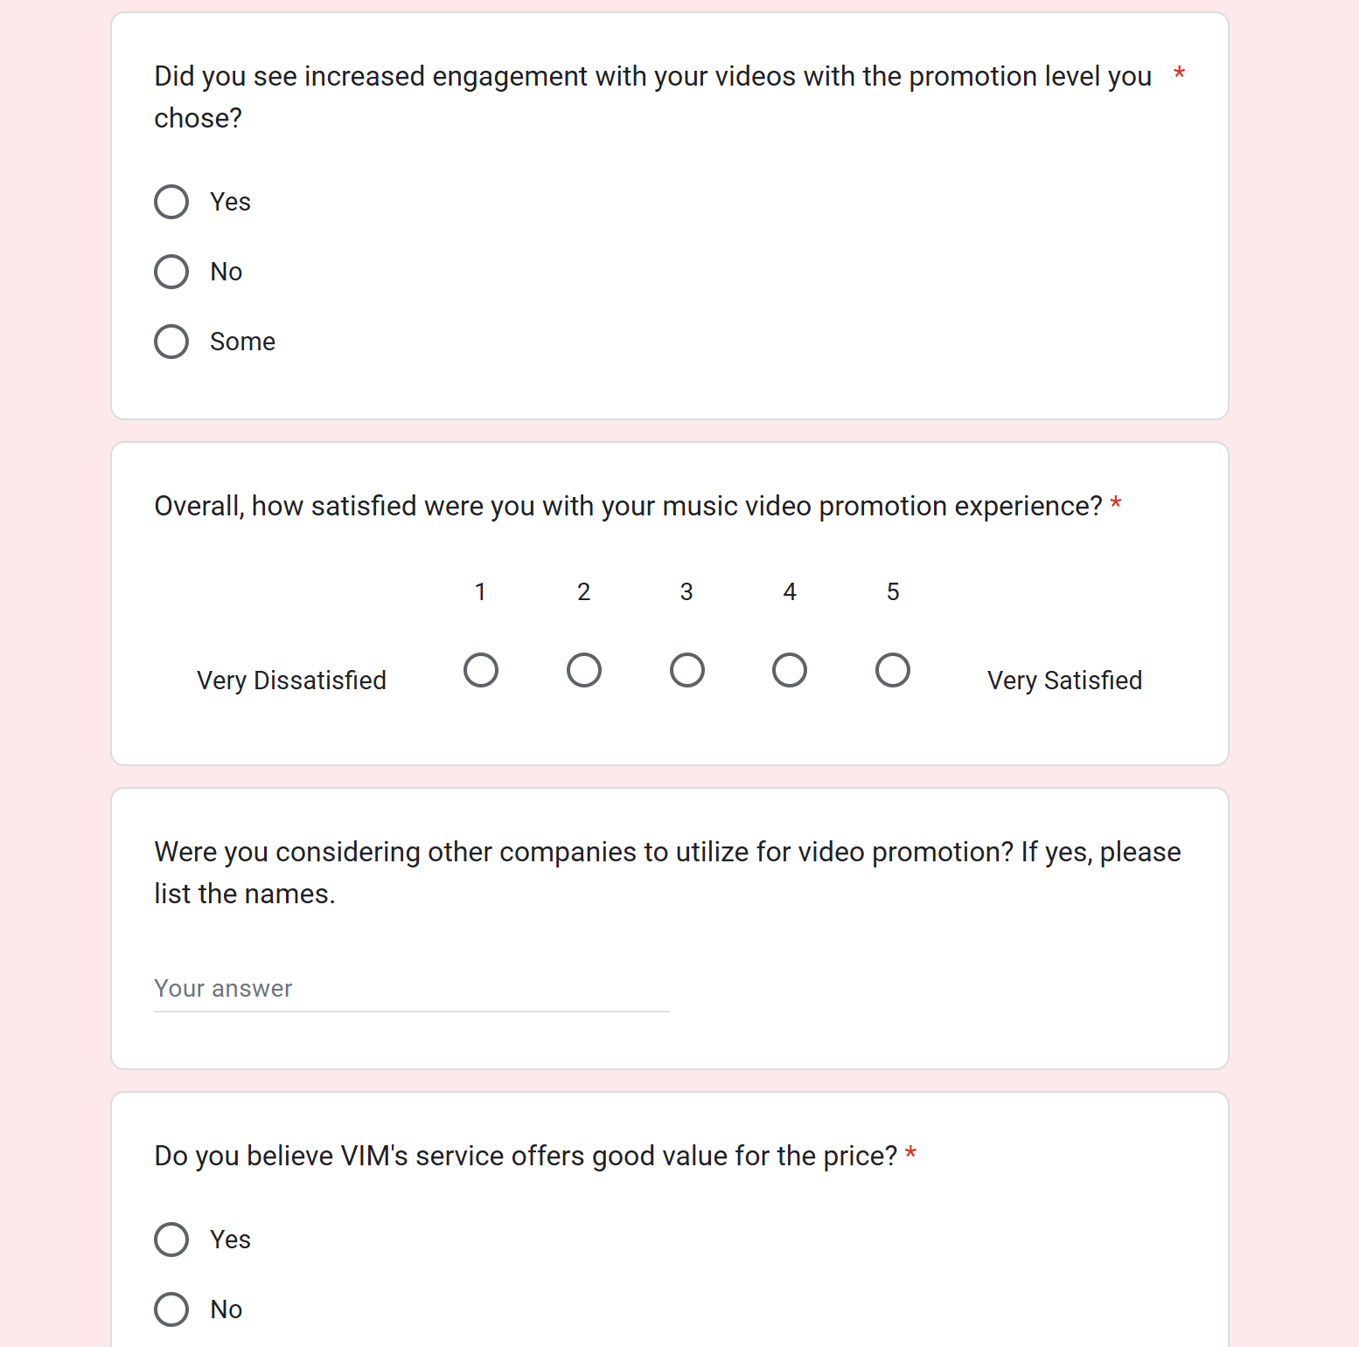
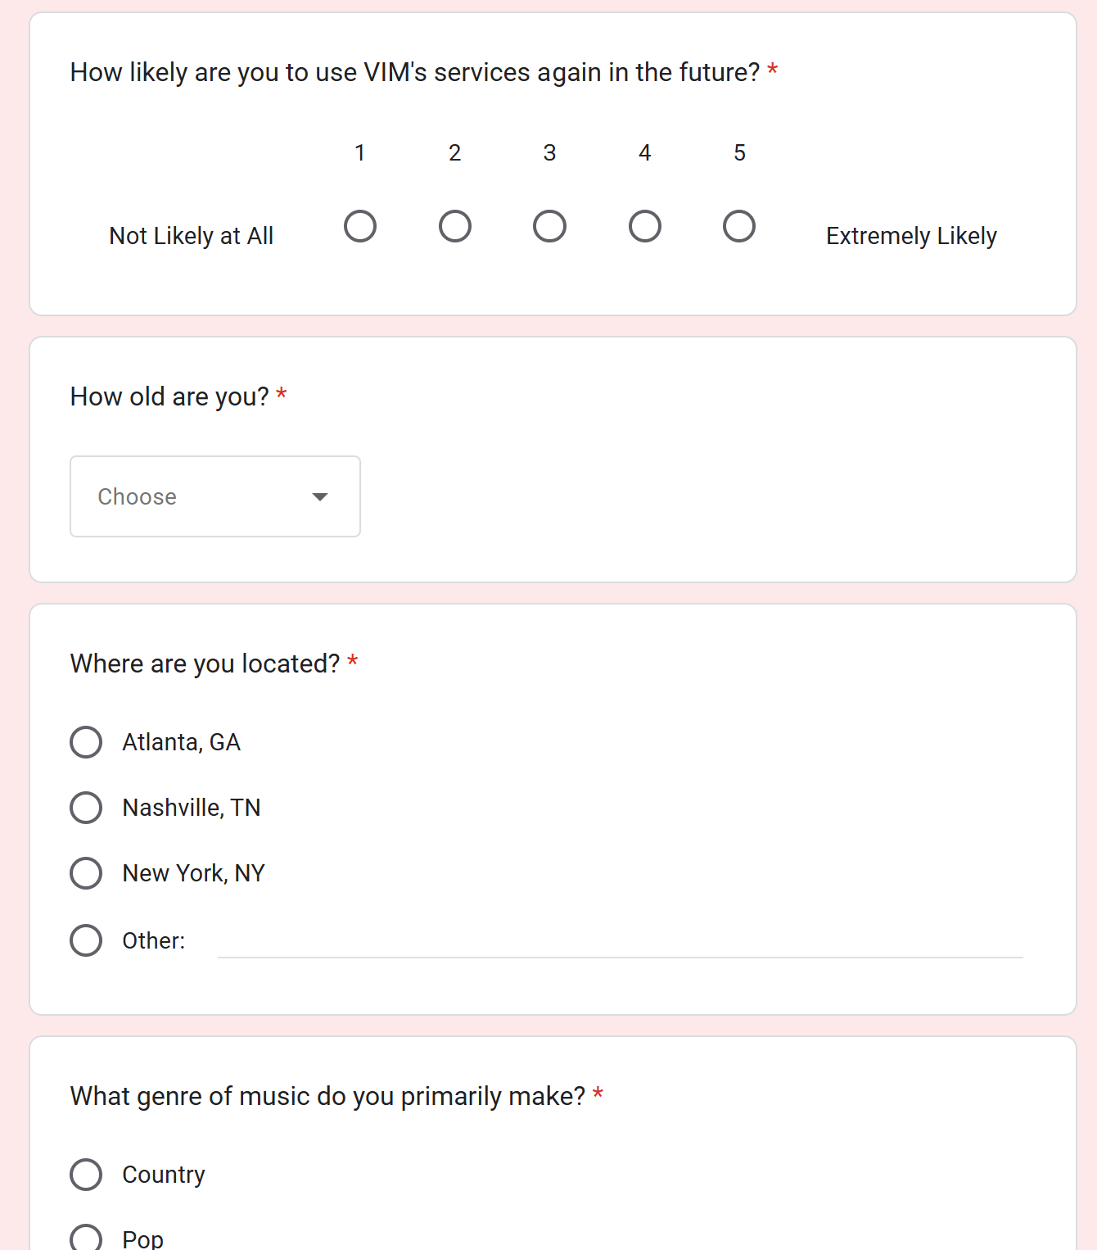
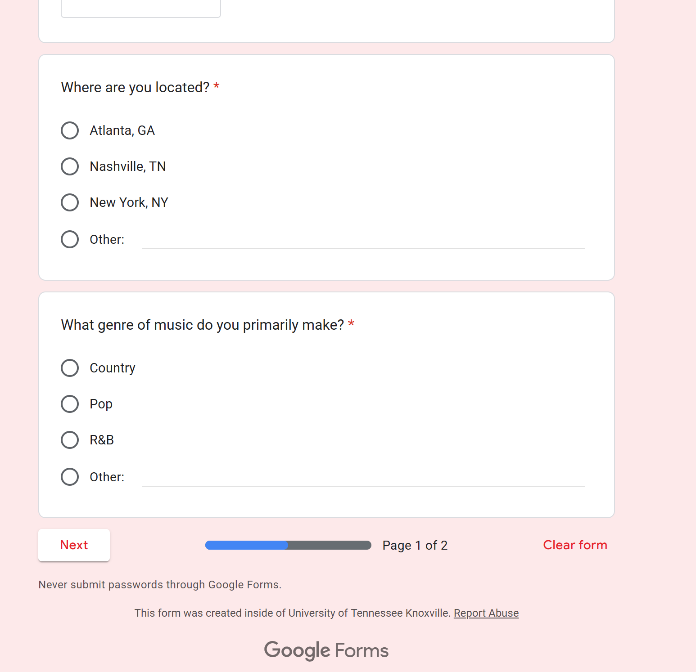
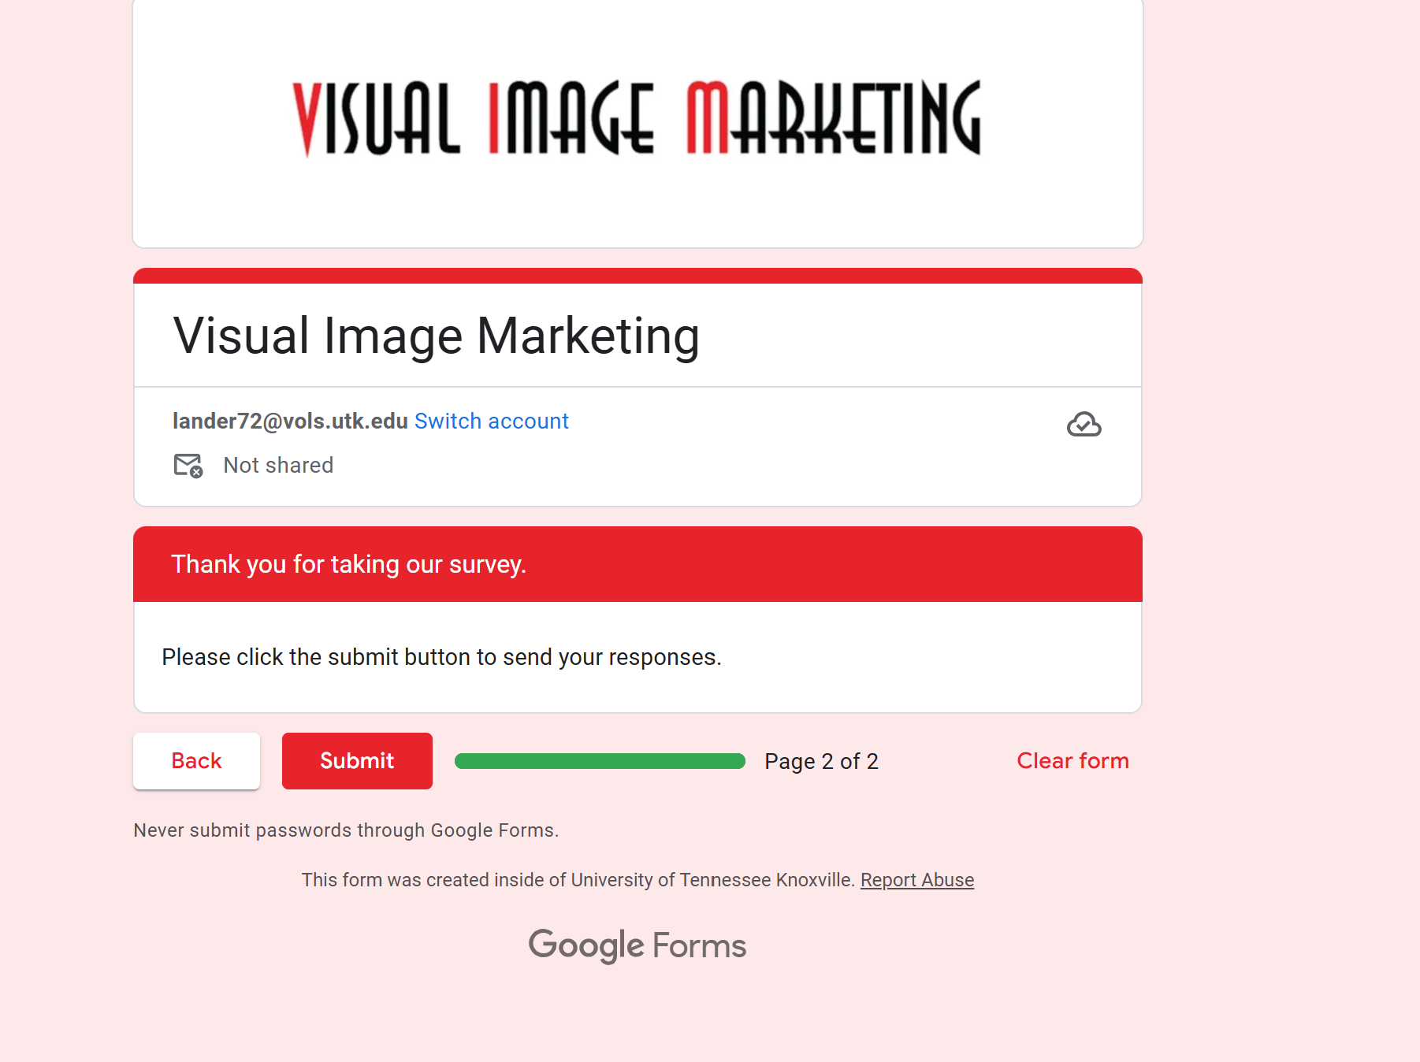
https://docs.google.com/forms/d/e/1FAIpQLSf_5BvFnBSaVIMcFTQAra7OahsJ7W5vntZiPibzBEEoFBQifw/viewform?usp=sf_link

